EXAMPLE FINAL
This is only an example of the kinds of questions you might encounter. These questions will not appear on the actual final and it will be multiple choice.

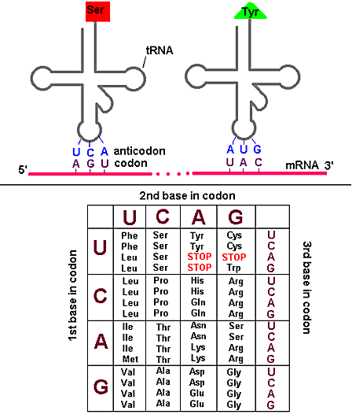
Q: Fill in the 3 blanks: Auxotrophic mutant mold colonies are isolated by a process known as
_____________________________________________ in which the growth of colonies plated on

________________________________________ is compared to the growth of colonies plated on

______________________________________

Q: Fill in the blank: The distance between two locations or sites on a strand of DNA can be mapped

genetically by measuring the ______________________________________________________ between the two sites.
Q: You have isolated a set of 8 individual auxotrophic mutant colonies that have the same phenotype, labeled A-H. You do a complementation analysis of this set of mutants and you get the results shown below, which show the results of all possible complementation tests. + means the cells grow; - means they fail to grow. (The results of all possible combinations of complementation tests are shown)
B C D E F G H
A + + + + - - +
B + + + + + +
C + + + + +
D + + + +
E + + +
F - +
G +
There are three parts to this question:
a) Which strains contain mutations in the same gene?

b) In the complementation analysis shown above, how many different genes are represented in this set of mutants?

c) Is it likely or unlikely that there are more genes in this auxotrophic pathway?
Q: You have isolated a new mutation in the T4 bacteriophage rII A gene and you map its location within the gene by recombination frequency. You find that this new mutation fails to give wild type recombinants with several different adjacent mutations located in the same gene. What type of mutation is this new one you just isolated?

Q: What happens to the concentration of a metabolic intermediate in a multi-step pathway at the step immediately after the reaction catalyzed by an enzyme when the enzyme has a mutation that blocks the enzyme activity?

Q: What type of mutations does acridine or proflavin dyes tend to produce in DNA?

Q: Which amino acids would you expect to find on the 3’ end of tRNAs that have an inosine residue in the anticodon?

Q: What is the predicted effect of a single base substitution mutation on the resulting protein structure if the genetic code was read in an overlapping fashion where the last two bases of the first codon are the first two bases of the second codon?

Q: What is the nature of the change in the DNA sequence of “revertants” to frameshift mutations? These revertants were created by the further mutagenesis of a frameshift mutant strain and selecting for strains with the wild type phenotype.

Q: Fill in the blanks: The genetic code is organizes such that single base substitution mutations have a

_________________ effect on protein structure and activity by substituting __________________ OR

_____________________ amino acids.

Q: What protein products are typically made when translating a synthetic repeating trinucleotide RNA in vitro?

Q: What must be added to cause a single specific amino acyl tRNA to bind to the ribosome when deciphering the genetic code?

Q: What are the products of the second step of the enzymatic reaction that is catalyzed by the aminoacyl synthetase?

Q: Fill in the blanks: Amino acids with side chains that are ________________________ for the amino
acid binding pocket sometimes react with ATP to form amino acyl adenylate but then fit into a second
_______________________________________ rather than being transferred to a tRNA.

Q: Why are 32 tRNAs the minimum needed to support protein synthesis? (In other words, what is the reasoning that leads to the conclusion that 32 tRNAs are the minimum required?)

Q: What are the anticodons of the tRNAs that are necessary to decode all of the codons for Cysteine and Tryptophan? Be sure to write their sequence in the conventional direction and specify which anticodons correspond to which amino acid.

Q: The following RNA sequence is a small part of a larger Eukaryotic mRNA that contains the 5' end of the protein coding sequence. What effect would the insertion of a C before the underlined G have on the translation of protein product encoded by the gene?
Wild type sequence:
UAGCUAGCUGACCAAAGGAGCCUCAACCAUGGGGCCCACUGAGCCUGAGCAGUUCCC
Mutant sequence:
UAGCUAGCUGACCAAAGCGAGCCUCAACCAUGGGGCCCACUGAGCCUGAGCAGUUCCC

Q: In which site on the ribosome is the initiation codon decoded?

Q: Which step of elongation follows immediately after initiation?

Q: What sites does the peptidyl-tRNA occupy on the ribosome immediately after peptide bond formation and before translocation?

Q: What is the function of EF-Tu in protein synthesis?

Q: What does the term POLYSOME refer to?

Q: Why can the N-formyl Methionine tRNA only be used for initiation and not elongation?

Q: Your biochemistry lab experiment failed and you suspect that your lab partner sabotaged it by poisoning your bacteria with an antibiotic that he is taking for his persistent cough. You isolate ribosomes from your poisoned bacteria under conditions which preserve the ribosomes and associated mRNA and you find that all of them are free ribosomes and none of them have growing polypeptide chains associated with them. Which antibiotic would you suspect that your lab partner is taking?

Q: What does the drug Puromycin do?

Q: What is the expression state of lac operon genes, Z, Y and A in a merodiploid analysis o with a lac O constitutive mutation with wild type lac operon in the absence of any inducer?

Q: What mediates the interaction between cis-acting upstream control elements and RNA polymerase in Eukaryotic transcription?

Q: What is an “epitope tag” used for?

Q: What part of the histone proteins is capable of being highly modified?

Q: What is responsible for removing most of the introns from Eukaryotic mRNAs?

Q: What proteins cooperate to export ribosomal RNA from the nucleus?

Q: What reaction does the enzyme Dicer carry out?

