Ann Liu
Professor Meriwether Clarke
Writing 39C
17 May 2015
Start Small, End Tall
Human trafficking remains as one of the most prominent issues of our society today as the globe’s fastest growing crime. About 20.9 million human trafficking victims are enslaved in our world today and between 600,000 and 800,000 victims are trafficked across international borders annually (Polaris Project). As the most developed nation in the world, with a very strong market-based economy, the United States is widely considered the major destination of victims of human trafficking because of its high immigrant population, wide international borders and airports, and concentration of formal and informal industries (Human Trafficking Search). According to the CRS report for congress, about 50,000 women and children are trafficked into the United States each year mostly from Southeast Asia and the former Soviet Union. To combat against this serious issue, the United States has passed many acts, policies, and laws including the Trafficking Victims Act of 2000, which is ranked as one of the most important human trafficking laws and the cornerstone of Federal human trafficking legislation (Polaris Project). Yet, the act proves to be rather ineffective as the number of human trafficking cases continues to rise within the past years despite increasing efforts of states promoting human trafficking awareness and complying with TVPA standards. The problems lies within the “certification” process of the TVPA, where law enforcement officers fails to identify victims and recognize the hidden nature of human trafficking. As a result, education and training of local law enforcement officers on the complex nature and forms of human trafficking, identification, and the support and assistance of trafficked victims are the most effective ways to improve the efficiency of government efforts to combat human trafficking.
Human trafficking is a form of modern slavery where people profit from the control and exploitation of others. The United Nations Office on Drugs and Crime, Article 3, paragraph (a) of the Protocol to Prevent, Suppress and Punish Trafficking in Persons defines human trafficking as the recruitment, transportation, transfer, harboring or receipt of persons, by means of the threat or use of force or other forms of coercion, of abduction, of fraud, of deception, of the abuse of power or of a position of vulnerability or of the giving or receiving of payments or benefits to achieve the consent of a person having control over another person, for the purpose of exploitation. Traffickers use violence, threats, deception, debt bondage, and other manipulative tactics to trap victims in horrific situations every day in America (The Polaris Project). Human Trafficking affects our world today with tremendous impact as it creates approximately $140 billion in illegal revenue annually (End Crowd). As a major hot spot of human trafficking, the United States is greatly at risk as 83% of victims in confirmed sex trafficking cases in the U.S. are U.S. citizens, between 100,000 - 300,000 children are at risk to be forced into the commercial sex industry in the U.S. each year, and 86% of U.S. counties with populations over 250,000 reported sex trafficking was a significant problem (Allies Against Slavery). According to WEAVE Inc., a provider of crisis intervention services for survivors of domestic violence and sexual assault, California, New York, Texas and Nevada are the top destination states for human trafficking with the U.S. To battle this severe issue, the United States has passed many laws and policies, eventually leading to the implementation of the Trafficking Victims Protection Act of 2000, which officially announced trafficking in persons as a federal act crime.
The Trafficking Victims Protection Act of 2000 (TVPA) was the stepping-stone to combating human trafficking for the United States but was also flawed in its nature. No comprehensive federal law existed to protect victims of trafficking or to prosecute their traffickers prior to the enactment of the TVPA. According to Creighton Law Review, The Trafficking Victims Protection Act of 2000 defines sex trafficking as the recruitment, harboring, transportation, provision, or obtaining of a person for the purpose of a commercial sex act. It is framed by the three “P”s consisting of prevention, protection, and prosecution. The prevention level carries out an annual report assessing the efforts of governments in meeting minimum standards in preventing trafficking. The protection level includes assistance programs providing medical services and hosing to victims. The prosecution level ultimately identifies and prosecutes sex traffickers. The TVPA was reauthorized with subsequences of the TVPA of 2003, 2005, 2008, and 2013 to increase its effectiveness of combating human trafficking. One of the major features of the TVPA is the T-Visa that it issues which provides “temperate residency for the victims and survivors and their family and eligibility to apply for permanent residency after three years” (Police Practice and Research). In order to qualify for the visa, “(1) according to the laws of the United States, the individual has to be defined as a "victim of sex trafficking;" (2) the individual must be in the United States or any other recognized country as defined by the law; (3) the individual, unless seventeen years old or younger (or physically incapable or if so traumatized psychologically), must agree to cooperate fully with law enforcement in regards to the inquiry and trial of the traffickers; and (4) the individual must be able to demonstrate that he or she would "suffer extreme hardship involving unusual and severe harm" if forced to return to her country of origin” (Creighton Law Review). This act was widely accepted as 39 states passed new laws to fight human trafficking in the past year and 32 states are rated in Tier 1, which requires the government to fully comply with the TVPA minimum standards, from 21 states in 2012 (Polaris Project). Yet, even though the number of states fulfilling the minimum standards of the TVPA have increased through the years, the results does not, however, correlate with this increasing trend.
The TVPA has proven to be inefficient as the number of trafficked victims continue to increase throughout the years. Out of the 50,000 women and children that are trafficked into the United States every year for sexual exploitation, only 228 victims received benefits under the TVPA in 2005 (Harvard Journal of Law and Gender). Also, nine years after the initiation of the TVPA of 2000, out of the tens of thousands of victims that were illegally transported into the United States on a yearly basis, only 1,300 trafficking victims had benefitted from the “T-Visa” status (Creighton Law Review). The reason lies within the certification process of the T-Visa, where law enforcement officers fails to identify the victims of the sex trafficking industry, figuring out who is a victim of a severe form of sex trafficking, and requiring mandatory assistance in prosecution of sex trafficker of traumatized victims. These impediments of the TVPA arise from the law enforcement officers’ insufficient knowledge of the hidden nature of human trafficking and the complex mental and physical states of the trafficked victims. As a result, the only way to improve the efficiency of government efforts to combat human trafficking is to train and educate law enforcement officers about the complex structure of human trafficking starting with local levels of police agencies and law enforcing departments.
The discovering and engagement of human trafficking should be managed at more local levels rather than mainly federal levels to increase contact with human trafficking victims. One of the major obstacles for proper training is a misconception that human trafficking is a big-city problem or an international issue. According to Police Practice and Research, only 12% of the police departments surveyed agreed that human trafficking was an significant issue for their department while 72% of the agencies believed that trafficking in human beings was best addressed by federal law enforcement instead. Yet, local governments in particular play a key role in improving human trafficking prevention, victim protection and prosecution of traffickers. While trafficking involves transnational crime, it is the local law enforcement officer, rather than the federal agent, who is most likely to encounter crimes such as prostitution that may be related to trafficking in human beings (Police Practice and Research). These local counter-trafficking leaders could be police officers, border guards, prosecutors, NGOs, development experts and more (Unitar). Since local law enforcement agencies such as the police are the ‘frontline’ of enforcement, they must be engaged in trainings and education, which are keys to “effectively identify potential victims, provide necessary assistance to current victims to help them undergo the rehabilitation process,” (Unitar). Yet, according to Police Practice and Research, which conducted a survey of the attitudes, trainings, and investigation activities of local police departments in the U.S., Few local law enforcement has preparation such as policies that deal with trafficking and general attitudes that promote active and informed responses to trafficked victims. Shockingly, only about 12% of the police department consider human trafficking a significant issue for their departments, only 8% reported that they had conducted or received training in human trafficking, and 96% did not have a policy that specifically addressed the needs of human trafficking victims. It is obvious that these crucial “front-line” enforcement agencies are ill prepared and are lacking “expertise, sensitivity or experienced personnel” (Unitar) to deal with the needs of human trafficking victims. It is clear that more education and training of local authorities are crucial in order to equip them with relevant skills and tools in to identify signs of trafficking and understand the appropriate follow-up actions.
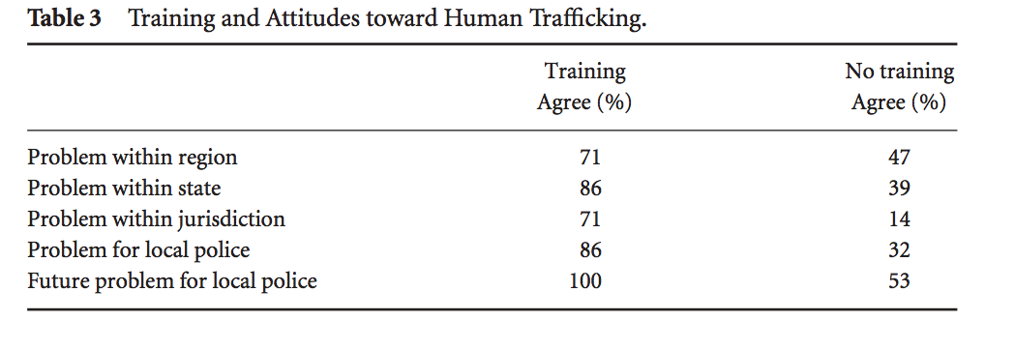
Training and education is extremely vital to increasing ability in combatting human trafficking. As DoD's Combating Trafficking in Persons program manager mentioned, "You might not think much of it before you take our training, but through increased awareness, you’re able to connect the dots a little more." (Huffington Post). According to Police Practice and Research, figure 1 shows significant differences in the awareness of human trafficking between agencies who have received training and those who have not.
Figure 1
Police Practice and Research
It is apparent that those agencies involved in training related to human trafficking had a more realistic perception of the perpetrators of the crime.
Training and education of law enforcement officers are extremely vital as trafficking networks have now become professional, entrepreneurial and less, which makes the detection of victims more difficult than ever before. As a result, law enforcement officials are often not approached directly by victims who are willing to testify. Thus, police forces need to be flexible, employing different investigative techniques to combat complex trafficking networks (CRS Report for Congress). Therefore, trainings should be concentrated on strengthening “the understanding of human trafficking as a crime and human rights violation” (Danish Red Cross) and “provision of relevant services such as secured accommodation, psychological assistance, access to interpreters and access to education” (Unitar). More importantly, trainings should adopt a victim-centered approach to countering human trafficking based on respect for human rights (Unitar) as many governmental officials see the victims as criminals (prostitutes) and find that the easiest thing to do is have the person arrested and charged with a crime (and where applicable, deported) (Creighton Law Review). Ultimately, trainings should be divided into two major parts: victim identification and support and assistance of victims.
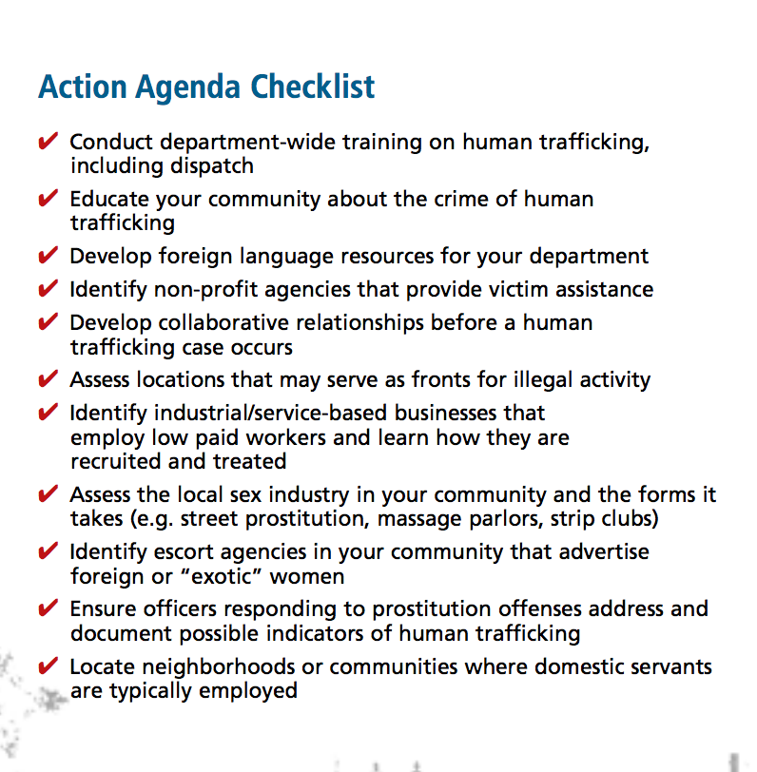
First part of training should emphasize on victim identification. One of the biggest failures of the TVPA is law enforcement officers’ inability to identify victims as “victims of human trafficking” due to insufficient knowledge and experience. These failures to identify victims at an early stage can result in inadequate protection of victims and consequently, prevent effective prosecution of the crime (Unitar). Therefore, training should emphasize creating a shared understanding of what trafficking is. First, it is crucial for law enforcement officers to understand the different forms of human trafficking. Traffickers can exploit humans for labor or services in a wide variety of forms and locations including sexual exploitations in but not limited to brothels, massage parlors and pornography productions and labor exploitation in but not limited to agricultural work, cleaning services and constructions (IACP). Second, it is important to train law enforcement officers to identify the means of control used by traffickers including “Violence and physical abuse such as frequent beatings, rape, confinement, deprivation of water, drugging or torture with knives, confiscation of travel or identity papers, economic penalties linked to debts, non-payment of wages, control of the victim’s bank accounts and finances” (Unitar). While these physical and psychological methods can indicate signs of human trafficking, it is crucial to remember that an individual that is not beaten or restrained physically may be a potential victim as well (IACP). Thirdly, the identification of the trafficked victims often depends on the attentiveness and alertness of law enforcement officers to minor signs of a potential or presumed trafficking situation. It is important to pay attention to state and federal violations such as “domestic violence crimes, labor disputes, prostitution and pimping offense, shoplifting and cases of assault” that may link to human trafficking (IACP). It is also critical to note that any individual such as legally working immigrants with work or student visas and U.S. citizens can be trafficked rather than just undocumented immigrants (IACP). Trafficking victims can include “U.S. citizens who are recruited and enslaved within the United States” and those who are “taken from the United States and trafficked into other countries” (IACP). Indicators of human trafficking can vary in different stages of human trafficking including the recruitment stage and the transfer stage. During the recruitment stage, law enforcement officers should recognize indicators in different locations such as rural and smaller towns, where victims are most vulnerable, as some may not be reached by awareness campaigns on trafficking. Indicators such as individuals in difficult family or personal economic social situations should be paid attention to and ask to share information about their situation to social services or employment authorities (Unitar). During the transfer stage, law enforcement officers should pay attention to indicators such as individuals coming from another region without a permanent residence and those claiming for replacement of lost documents. Also, it is important to observe the security, working conditions and appearance and mannerism of the workers within the businesses their communities as human trafficking are often hidden under the façade of legitimate businesses (IACP). Figure 2 gives a sample of action agenda checklist that local law enforcement officers should practice to discover indicators in their community. Along with victim identification, trainings on victim support and assistance is extremely important as well.
Figure 2
IACP
The second part of training should focus on the support and assistance given to victims. First, law enforcement officers should understand victims might be reluctant to try to escape and receive help at encountering due to many factors. They may “fear law enforcement because of their illegal status, mistrust law enforcement because officers in their home country may be corrupt, choose to remain in the situation to keep family safe from retribution, may not perceive themselves as victims because they do not know their rights, believe that any debts are their obligation to repay, and feel shamed to admit victimization” (IACP). Therefore, it is very important for law enforcement officers to be trained to not violate human rights or reduce the dignity of the victims. Even though it is stated that “trafficked persons cannot be prosecuted or punished for committing crimes under the period of their victimization or as consequence of trafficking” (Unitar), in reality, many trafficked victims have been treated as criminals in both the destination and home countries for having used false documents, having worked in the sex industry, or having left the country illegally. As suggested by the United Nations Institute for Training and Research (Unitar), training of supporting and assisting victims should be divided into several steps. The first step should be the initial referral of any presumed victim to a responsible body to ensure protection and safety. Law enforcement officers should be closely connected to hotlines and nonprofit organizations such as the “Coalition to Abolish Slavery and Trafficking (CAST)”, “Coalition of Immokalee Workers”, and “Trafficking Information and Referral Hotline” to maintain close contacts with potential trafficked victims (IACP). The second step should be ensuring victims’ accessibility to basic needs and information such as “health care, a bed to sleep on, counseling an immediate protection for themselves and their family members”. In some places, the shelters for trafficked victims closely resemble detention centers more than safe havens, which can potentially create re-traumatization (Unitar). It is important to provide victims comfortable place where they can stay, leave and return according to their wish and also provide services catered to their specific needs. The third step should focus on the early risk assessment of victims by reviewing possible risks and securing immediate safety for the victims. Victims may be in danger as a result of variety of factors including the “extent of the trafficking operation, the trafficker’s perception of how damaging a victim’s testimony may be, and the trafficker’s propensity to use violence” (IACP). Therefore, law enforcement officers should work with victims to address and plan for their safety to avoid re-traumatization and build trust and relationship. The fourth step should be ensuring clear language and interpretation in a language that the presumed victims understand. Lastly, the fifth step should establish a provision of the time and resources needed for the recovery and reflection period of the presumed victims so decisions for future plan can be made. One of the biggest flaws of the TVPA was the mandatory assistance in the investigations and prosecutions of the victims as law enforcement officers fail to realize the post-traumatic stress disorders many of them have and fear of retaliation of family member contributes greatly to their unwillingness to testify, therefore disqualifying them from the T-Visa (Creighton Law Review). As a result, law enforcement officers should not force victims participate in criminal investigations unless it is under their free volition. Long-term assistance should not tell the victim what they can and cannot do but provide help to victims in reaching their personal goals in a flexible and adaptive manner (Unitar). Ultimately, support and assistance of victims are crucial in protecting the victims’ dignity and wellbeing as well as in assisting in the prosecution of the traffickers.
Human trafficking is a severe hidden crime that violates victims’ rights to life, liberty and security. It has been affecting our world globally and locally, socially and economically. Despite the many effort of the U.S. government has put in to combat human trafficking, it still remains as one of the fastest growing crime in our country. As the problem lies within the trafficking laws of the U.S., the most effective ways to combat against it will be the education and training of law enforcement officers’ especially local enforcement agencies. To combat such a wide spread phenomenon, actions must be taken from the smallest factors such as us individuals to end this global nightmare.

Work Cited

Chung, Dal-ho. "Human Trafficking and the Role of Local Governments." United Nations Institute for Training and Research. Web. 1 May 2015.

Claudia, Aradau. "Good Practices in Response to Trafficking in Human Beings." Danish Red Cross. Web. 1 May 2015.

"Facts about Human Trafficking." WEAVE Inc. Web. May 2015.

Friesendorf, Cornelius. "Strategies Against Human Trafficking: The Role of the Security Sector." National Defence Academy and Austrian Ministry of Defence and Sports, 1 Sept. 2009. Web. 1 May 2015.

George, Shelly. “The Strong Arm of The Law Is Weak: How The Trafficking Victims
Protection Act Fails to Assist Effectively Victims Of The Sex Trade. “ Creighton Law
Review 45.3 (2012): 563-580.Academic Search Complete. Web 20 May. 2015

"Human Trafficking." Polaris. Web. 27 May 2015.

"Human Trafficking Is Still Globe's Fastest-Growing Crime Despite Increased Awareness." The Huffington Post. Web. 1 May 2015.

"Human Trafficking & Slavery: Facts & Stats." End Crowd. Web. 1 May. 2015.

"Human Trafficking Resources for Law Enforcement." Virginia Department of Criminal Justice Services. Web. 1 May 2015.

"Human Trafficking Legislative Issue Brief: Law Enforcement Training on Human Trafficking." Polaris Project. Web. 1 May 2015.

Miko, Francis. "Trafficking in Women and Children: The U.S. and International Response." CRS Report for Congress, 18 Mar. 2002. Web. 1 May 2015.

Pierce, Sarah. "Top 4 States for Human Trafficking." Human Trafficking Search. The Global Resource & Database, 1 Nov. 2014. Web. 1 May 2015.

Rieger,April. "Missing the Mark: Why the Trafficking Victims Protection Act Fails to
Protect Sex trafficking Victims in the United States. Harvard Journal of Law &
Gender 30. Print. May. 2015

"Slavery In the United States." Allies Against Slavery. Web. 1 May. 2015.

"The Victims." NHTRC National Human Trafficking Resource Center. Web. May 2015.

Viverevette, Mary. "The Crime of Human Trafficking: A Law Enforcement Guide to Identification and Investigation." International Association of Chiefs of Police. Web. 1 May 2015.

"What Is Human Trafficking?" CASE Act. Web. May 2015.

Wilson, Deborah G., William F. Walsh, and Sherilyn Kleuber, “Trafficking In Human Beings: Training and Services Among US Law Enforcement Agencies.” Police Practice & Research 7.2 (2006): 149-160. Academic Search Complete. Web. 19 May 2015.

