Ann Liu
Professor Meriwether Clarke
Writing 39C
15 April 2015
Sex Trafficking and its Laws in the U.S.
About 85% of sex trafficking cases victims in the United States are referenced as women according to Polaris Project, a foundation that disrupts the conditions that allow human trafficking to thrive in our society. According to Gomez’s research, the U.S. government estimates that 50,000 women and children are trafficked each year into the United States primarily from Latin America, Russia, the New Independent States, and Southeast Asia. From such disturbing statistics, it is even more shocking to find them in one of the best quality of life and standard of living country we live in today. As the United States is viewed as a diverse country, it is not surprisingly to find a diverse background of women in the sex industry. According to “Sex Trafficking in the United States”, one of the main research project I will be citing from, the women interviewed in the study were predominantly from the former Soviet Union (13 of 15), and over half of the U.S. women were African American (13 of 25). Sex businesses can be found in diverse areas such as “urban, suburban and rural, as well as areas surrounding U.S. military bases” (Gomez). These sex businesses are advertised in mainstream medias such as “newspapers and periodicals, pornography magazines, sex guides, the Yellow Page, and billboards” (Gomez). Operational wise, sex business are operated through “street prostitution, escort services, massage parlors, health clubs, brothels in hotels, rented houses and apartments and legitimate front businesses…” (Gomez). It is apparent that sex businesses are just as publicly recognized and operated as other normal business in the U.S.. Yet, the illegal and corrupted nature of sex businesses are not the businesses themselves, but the way they operate their businesses – through the use of sex trafficking, which is “not only force or coercion, but abuse of the vulnerability of victims, are conditions that promote trafficking” (Gomez). In my research paper, I will be explaining how sex trafficking not only affects the victim but the U.S. as well as the “costs to society include the degradation of human and women’s rights, poor public health, disrupted communities, and diminished social development” (Deshpande).
According to Fair Observer, nonprofit organization that aims to inform and educate global citizens of today and tomorrow, in 2000, the United States passed the Trafficking Victims Protection Act (TVPA) and the United Nations adopted the Protocol to Prevent, Suppress and Punish Trafficking in Persons, Especially Women and Children. This law officially recognizes sex trafficking as a national and international crisis. The TVPA has three levels: prevention, protection, and prosecution. Prevention is governed by the TVPA's promise to put out an annual report assessing the efforts of governments in meeting minimum standards in preventing trafficking. Yet, the crime of sex trafficking does not cover sexual violence that is unrelated to commercial sex acts. For example, there are many examples of women, girls, and boys who are kidnapped, raped, and held captive, but unless they are used for a commercial sex act, they are not considered to be victims of sex trafficking, which makes majority of the victims still invisible to our society’s awareness. According to Human Rights for All, from 2000 to 2008, as part of its response to both human trafficking and the global HIV epidemic, the U.S. government developed anti-prostitution policies and Congress passed anti-prostitution provisions that directly undermine U.S. efforts to prevent trafficking and HIV/AIDS as the focus of these policies is directed at stopping women from selling sex to earn a living. However, sex work is not the same as human trafficking into the sex sector and should not be conflated as such. Conflating human trafficking with prostitution results in ineffective anti-trafficking efforts and human rights violations because domestic policing efforts focus on shutting down brothels and arresting sex workers, rather than targeting the more elusive traffickers. The problem will therefore never be solved if the U.S. do not target sex trafficking from its roots.

In the U.S., a country that emphasizes on personal freedom and rights, sex trafficking majorly violates this value with its nature of operation – the suppression of women’s rights. As a result of push factors such as “burdens and liabilities, and lack of family support, or direct family pressure or coercion” (Gomez), trafficker allure women into the sex industry with false promises of money and opportunity. Once successfully tricking these women into the industry, traffickers use methods of control including “denying freedom of movement, isolation, controlling money, threats and intimidation, drug and alcohol dependencies, threatened exposure of pornographic films, and physical and sexual violence” (Gomez) to restricts the women from escaping. According to Gomez, the majority of law enforcement (76%) and social service providers, advocates and researchers (71%) confirmed that a large number of women were not free to leave the sex industry. One of the most used intimidation method is violence, which research shows “eighty-six percent of U.S. women, and 53 percent of the international women reported being physically abused by pimps and traffickers” (Gomez). Not only physically, “one half of the U.S. women, and 1/3 of the international women described frequent, sometimes daily assaults. Eighty-eight percent of U.S. women and 50 percent of international women reported psychological abuse. Ninety percent of the U.S. women and 47 percent of international women reported verbal threats” (Gomez). Sex trafficking significantly violates U.S.’s value of freedom of individuals as well. According to Gomez’s research, many women (international women—50%, U.S. women—43%) tried, sometimes multiple times, to leave the sex industry. Twenty-seven percent of the international women and 52 percent of the U.S. women said economic necessity, drug dependencies and pimps who beat, kidnapped, and/or threatened them or their children prevented them from leaving.

Not only are the victims themselves negatively impacted, the “buyers” and ultimately, the public is affected as well health wise. According to Gomez’s research, almost half of the international and U.S. women (47% each) reported that men expected sex without condoms. Fifty percent of the international women, and 73 percent of U.S. women reported that men would pay more for sex without a condom. A significant portion of the international (29%) and U.S. (45%) women said that men became abusive if women tried to insist that they use condoms. According to Human Rights for All, a growing body of research finds that sex workers’ high risk of HIV infection is due in part to their marginalized and illegal status. Criminalizing sex work thwarts workers’ access to health care services and government benefits and makes them vulnerable to police abuse and exploitation. The physical health of trafficked women are significantly affected as well as “almost half of the U.S. women (47%) reported head injuries. Thirty-six percent of the international woman and 53 percent of the U.S. women reported mouth and teeth injuries. Fifty-six percent of the U.S. women required emergency room treatment for injuries and illnesses sustained while in the sex industry” (Gomez). Also, emotionally, “Eighty percent of international and U.S. women felt depressed. Many of the international (50%) and U.S. (41%) women felt hopeless. Almost 1/3 of the international and 64 percent of the U.S. women experienced anger and rage. Sixty-four percent of U.S. women said they had suicidal thoughts and 63 percent said they had tried to hurt or kill themselves”
(Gomez).

Not only does U.S. law ineffectively targets the wrong aspect of sex trafficking, the consequences stigmatizes sex work as well. According to Human Rights for All,
laws, policies, and attitudes that criminalize sex workers perpetrate human rights violations and actually work against creating safe and healthy communities. As illustrated in this publication, when sex work is illegal, sex workers face societal and legal barriers in accessing safe housing, other forms of employment, birth certificates for their children, and health care services, including HIV/AIDS prevention, treatment, and care. Criminalizing sex work also puts sex workers at an increased risk of violence, be it perpetrated by clients, brothel madams, or even law enforcement officers, and makes it challenging to pursue protection.
One of the biggest flaw of U.S. sex trafficking laws are their failure to recognize the desperate and voluntary nature of sex trafficking victims. According to Struensee, Some women may end up as victims of trafficking and exploitation through officially legal routes. In other instances, women knowingly agree to migrate for work in the sex industry, but then are coerced into debt bondage where they are forced to repay their trafficker and/or employer for transportation and other "fees." Further, because these women may have entered the U.S. or other countries illegally and are often working in an illegal industry, they are afraid to turn to local authorities for help and are unable to file civil suits against their abusers or have access to other protections provided by labor laws. In such cases, the criminalization of prostitution where the victim prostitute is prosecuted "adds to the burden of women who are already victims," noted Mary Robinson, UN High Commissioner for Human Rights.
In conclusion, sex trafficking in the U.S. has made its way to affect not only the victims but also society itself. Yet, the laws enforcing sex trafficking have instead prove to be inefficient as it contradicts with the nature of trafficking as victims are targeted to illegal means for their voluntary and desperate natures. The only solution to solving this problem will be execute these laws differently in a way victims would not be victimized instead.

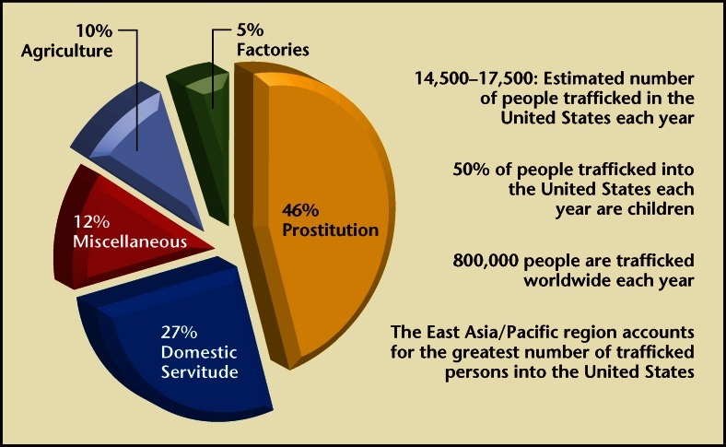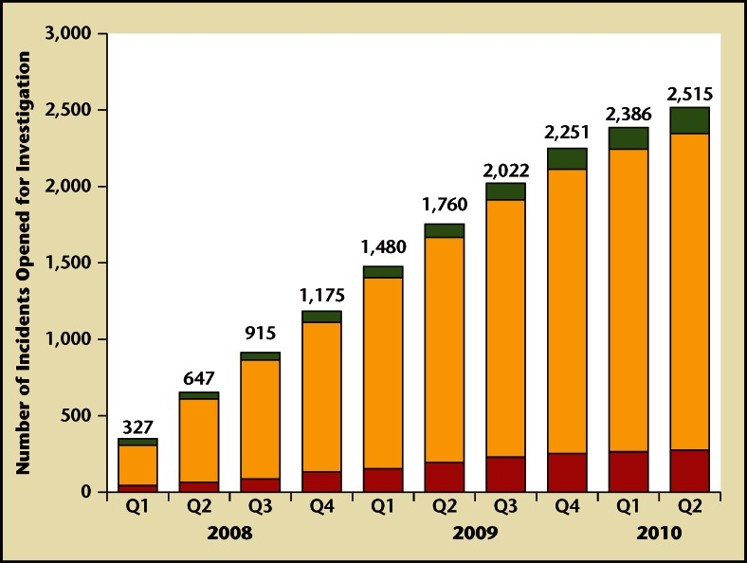

Work Cited
Gomez, BA, Carol J. "SEX TRAFFICKING OF WOMEN IN THE UNITED STATES." Coalition Against Trafficking in Women (2001): 141. Print.

http://www.polarisproject.org/human-trafficking/sex-trafficking-in-the-us
http://www.murdoch.edu.au/elaw/issues/v7n2/struensee72.html
http://www.ncbi.nlm.nih.gov/pmc/articles/PMC3651545/
http://www.fairobserver.com/region/north_america/combating-sex-trafficking-history/

http://www.genderhealth.org/files/uploads/change/publications/Human_Trafficking_HIVAIDS_and_the_Sex_Sector.pdf#search=Sex Trafficking
http://web.ebscohost.com/ehost/pdfviewer/pdfviewer?sid=df3126d6-3649-4bd7-9140-10f4ec6def20%40sessionmgr4005&vid=9&hid=4212

