Kevin O’Leary
Professor Ramon
Writing 39B
12 November, 2016
Reflecting on the Fundamentals of Framing
Framing quotations that will be used directly in academic writing is necessary as it allows the quote to be correctly embedded so that the reader can understand its meaning. Matthew Hedstrom from the University of Oregon observes that, “Framing quotations that will be used directly in academic writing is necessary as it enables the quote to be implemented correctly so the reader can make sense of it” (1). Framing should include who is speaking as well as details of how/under what circumstance they are speaking. This allows for the reader to eventually understand the reason why the quote was used. Several of my works include both effective and ineffective ways of framing quotations, such as in my rhetorical analysis, “Murder, Mystery” paragraph, and rhetoric in practice essay. My rhetorical analysis, from my preliminary drafts to the final, lacked detailed framing, which disallows the reader to make sense of the quote. Both my “Red Wind” review and “Murder, Mystery” paragraphs contain framing but lack the depth needed for an academic essay. After having several opportunities to practice framing, I had learned to do so effectively throughout my RIP (rhetoric in practice) essay. Before learning the fundamental characteristics of writing, my quotation framing would typically include vague details, such as who is speaking; however, it can be seen through various drafts of my writing that I now understand how to embed quotations properly by using rhetorical strategies to orient the way in which the audience interprets the dialogue.
From the initial draft of my first body paragraph to the final draft of my rhetorical analysis, the framing of my quote given the rhetorical strategies I used as well as the level of detail I implemented improved significantly; however, the framing in my first draft contained several errors which I have identified. In the first draft of my body paragraph, I did not use any form of rhetorical strategy to frame my quote nor did I provide the details of where and under what circumstance Walter Neff from Double Indemnity speaks, which can be shown when I write:

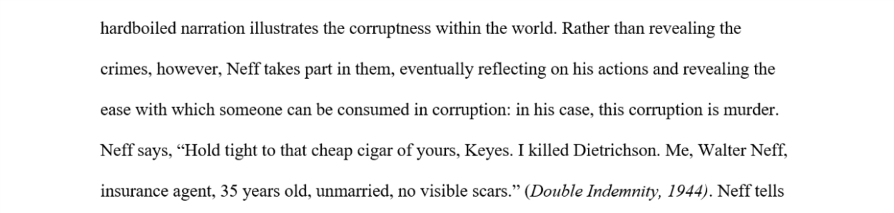

Rather than describing the way Walter Neff speaks, I say “Neff says.” In addition to this, I lead up to the quote by stating that Neff reflects “on his actions” and reveals “the ease with which someone can be consumed in corruption.” The actual quote, however, does not represent how he reflects on his actions nor does it reveal how corruption consumes someone. Mathew Hedstrom, while describing how to frame quotations, says, “Framing can do much more than provide simple attribution” (2). In my first draft of this framing, I did not do more than identify the author. I also failed to use the proper rhetoric to guide the reader into understanding the quote, which implies that my embedding was ineffective for this draft of my body paragraph. Effective embedding should allow the reader to visualize the quotation, and it should imply its significance to the reader. However, I failed to do this, and it took several revisions of different essays to grasp this concept.
The framing within the final draft of my rhetorical analysis is more effective than my first because it fixes some of the major issues surrounding the lack of detail and rhetoric. In the fourth paragraph of my final draft, I begin to frame the quote by describing the way Marlowe from “Red Wind” narrates as well as the situation he is in by writing:

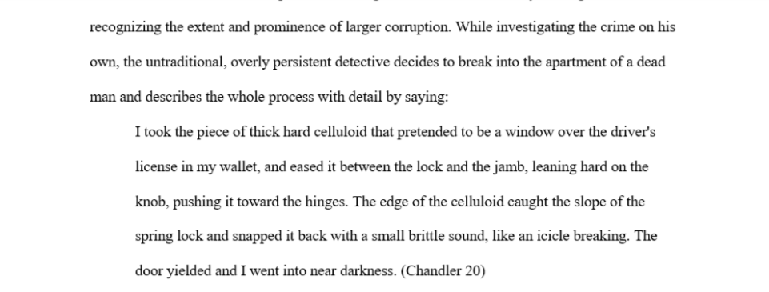

I describe when Marlowe begins to narrate after I say “While investigating the crime on his own.” I also state how Marlowe conducts his investigation by breaking “into the apartment of a dead man.” Using these words are effective because they allow the audience to understand and visualize the situation of the quotation. They were also used as a form of rhetoric to guide the reader into picturing the narrator committing a crime, allowing them to eventually conclude that it is very easy for someone to be encapsulated in corruption. This was the overall idea of the paragraph, and using certain forms of rhetoric within the framing of the quotation effectively guides the reader into recognizing the idea that I am proposing.
Another example of framing that was particularly ineffective, due to the fact that it lacks several components relevant to the actual quote, was used in the fifth paragraph of my rhetorical analysis. In this paragraph, as with several other paragraphs, I attempt to frame the quotation simply by providing who is speaking and what he is saying, such as when I write:

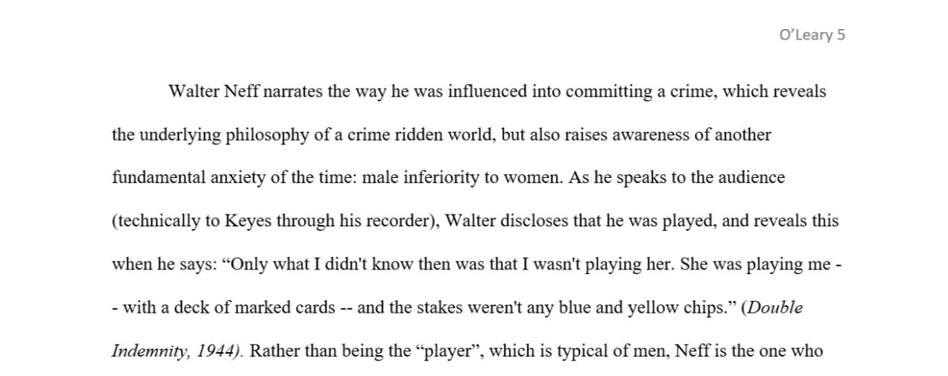

Within my framing, I did not address any reason for using the quotation, but rather spent time addressing the fact that Walter “speaks to the audience” and “reveals” that he was played. Stating that the narrator simply reveals something and speaks to an audience is not specific enough to inform the reader of how the quotation is relevant. Harvard University’s writing program expresses the idea of addressing the reason for a quote when they state that “Every quotation you use in your paper should be introduced with a sentence of your own that alerts the reader to your reason for using the quotation” (“The Nuts and Bolts of Integrating”). I do not ever specify the reason for why I use the quote, causing my framing, based on their rules, to be considered ineffective. Had I used another approach to inform the reader of my reasoning for the quote while simultaneously introducing the speaker, it could have been a more successful paragraph overall.
My “Murder, Mystery” paragraph represents a situation in my writing where the framing of the quote I used contains both positive and negative aspects concerning rhetorical choices and introduction of the speaker. Intending to reveal how the short story questions the meaning behind what classifies something as noir or neo-noir, I framed the quote by writing:

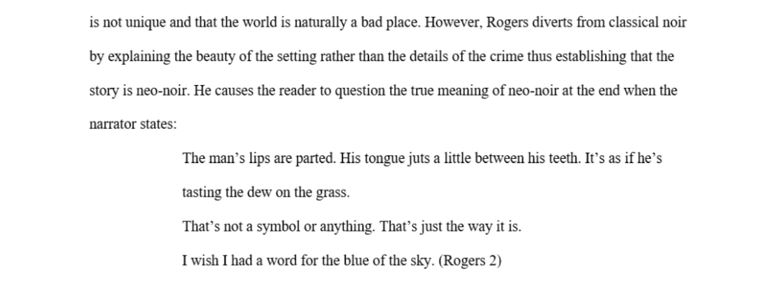

By stating that he (the author) “causes the reader to question the true meaning of neo-noir”, I give insight as to what effect the quotation will eventually have on the reader. Doing this is fundamental for the reader of my essay to fully understand the meaning of the quote. However, this does not give them the reason as to why I used the quote. Additionally, the sentence prior to my framing distracts the reader from the quote rather than gradually transitioning into it by providing relevant information. If I combined the two sentences and embedded reason for the quote within my framing, it would subsequently have a greater effect, and therefore the paragraph would be more successful. Embedding the quote fluidly utilizes several rhetorical strategies, which ultimately engages the reader and keeps his/her focus on the main idea of the paper.
There are several instances in my RIP essay where it is necessary for me to utilize framing. However, the piece of information that I am framing comes directly from the project itself in the form of a screenshot, which can be seen here:
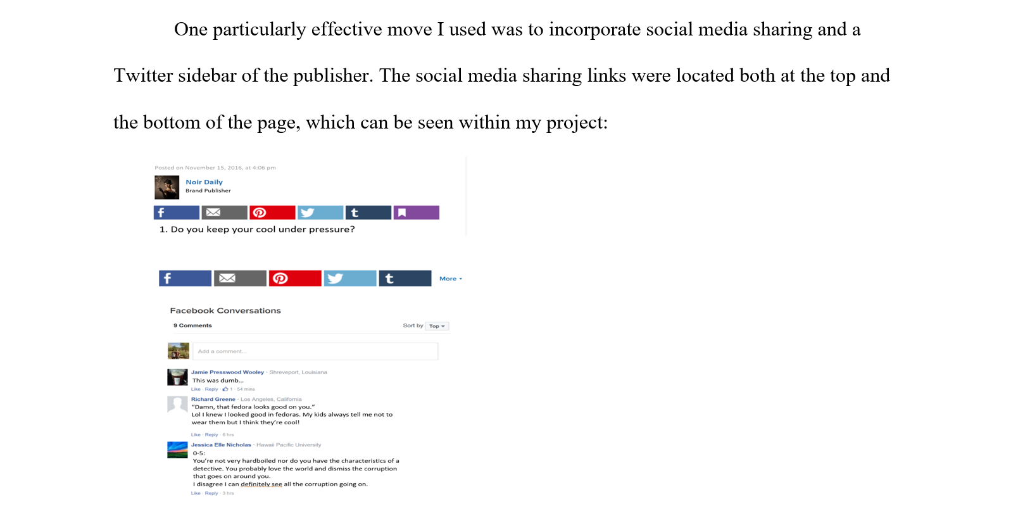
Within my framing, I state that the “social media and sharing links” were at the “top and bottom of the page”. In addition to this, I inform the reader that this can be found within my project before giving a screen shot of their location. Much like framing an actual quote, I provided the reader with information pertaining to what the image was and how it was relevant to the paragraph. It seems, however, that I could have provided more information about the relevance of the image while embedding it. Regardless, this example of framing was successful because it follows the rules I have discussed thus far. It is harder to gauge whether this piece of embedding was effective because it is unique to the RIP essay; the evidence comes from direct screenshots originating within the project itself. The importance of embedding persists even if its purpose is to frame an image that will eventually be analyzed. Audience awareness pertaining to understanding their ability to comprehend the relevance of the image and its content persists.
Surprisingly, the use of effective framing can be seen within my RIP project, proving that framing can exist even for sources that are not being directly quoted. I utilize framing within my RIP project in a very informal, yet effective way, which can be seen here:
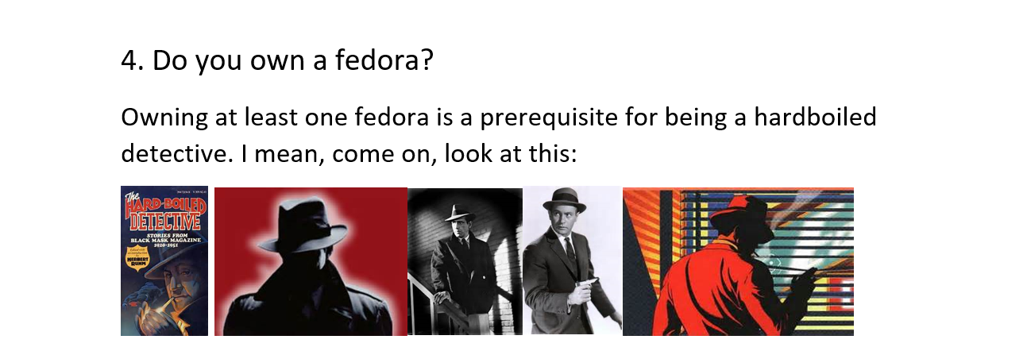
In this example of framing, I lead the audience into several pictures, such as when I say “I mean, come on, look at this.” I then show a series of images relating to the point I was trying to make, which was that owning a fedora was a “prerequisite for being a hardboiled detective.” Although it seems that this is very informal and goes against some of the framing “rules” established throughout the class (which it does in some ways), I would consider this an effective piece of framing because the point of it is to appeal to the young crowd that dominates Buzzfeed. Using wording like “come, look at this” is effective in allowing the audience to feel a sense of connection to the quiz, as if the person who wrote it belongs to the group that they are in and thus is credible. I believe this is a great example of how framing an untraditional, non-quoted source can be successful in giving a representation of the overall point the image is meant to portray and how showing this is relevant to the piece.
Cumulative of all the assignments and drafts throughout the quarter, my most effective piece of framing comes from the first body paragraph of the final draft of my rhetorical analysis, in which I utilize several techniques to properly embed my quote into the paragraph. The overall goal of this paragraph was to show how hardboiled narration allows the reader to understand and see corruption through the eyes of someone who witnesses crime first-hand. To influence the reader into understanding the meaning and purpose of the quote, I wrote:

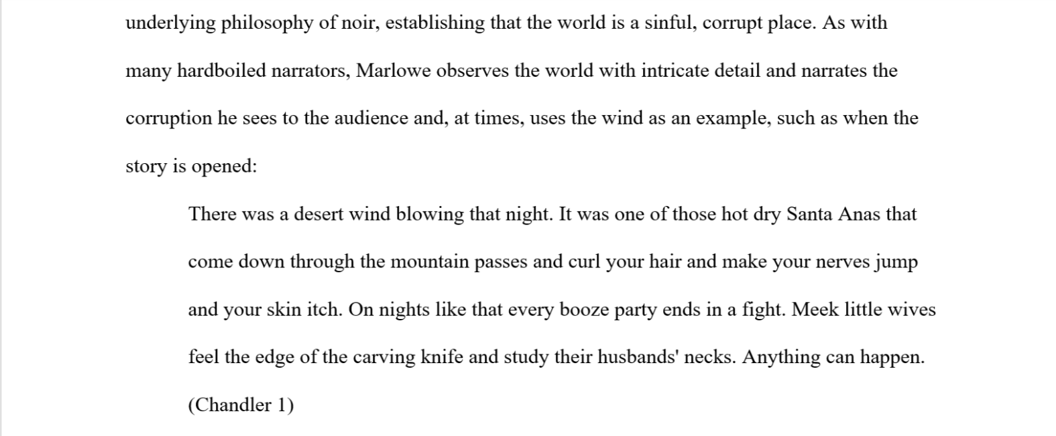

I state that "As with many hardboiled narrators", Marlowe has the ability to "observe the world with intricate detail". Not only this, but Marlowe also "narrates the corruption he sees" to the reader while using the "wind as an example". To say that Marlowe can observe this world of corruption while simultaneously narrating allows the reader to understand that the world will be seen through his eyes. The reader can trust his interpretation of the world because I state that he observes with detail. However, the overall goal of the quote is to inform the reader that the world is corrupt, which is successfully incorporated into the embedding when I describe that he explains this world while describing the Santa Ana winds. Informing the audience (before they read the quote) that the wind parallels crime allows them to understand the quotation as they read it. The framing within the paragraph exemplifies a situation where I implemented rhetorical strategies to inform the reader of the purpose behind the quote while implementing a visual effect that enables the reader to picture who the speaker is. Doing this made the framing of my paragraph successful because the reader can understand the full effect of the quote due to the smoothness of the transitioning as well as the detailed explanation of what the quote is and who it comes from.
Quotation framing is a vital component of any essay. The ability for a writer to implement awareness of his/her audience’s ability to understand a quote increases credibility and establishes meaning for a source. After several drafts of various assignments, I now understand how to effectively frame a quotation (or image), as can be seen through the reflections on my work thus far. Framing is also a vital part of this essay, which is slightly more difficult to do successfully considering that I am using my own writing as a source. To be successful as an academic writer, it is essential for me to recognize the positives and negatives within my own writing and equally important to identify what specifically appeals to the readers of my own essays should I want my writing to have some effect on a particular audience. Being able to frame quotations is just one of many components of an academic essay that has a substantial impact on a writer’s ability to persuade.

Works Cited
"Harvard Guide to Using Sources." The Nuts & Bolts of Integrating §. Harvard
University, n.d. Web. 12 Nov. 2016.
Hedstrom, Mathew. "Using and Forming Direct Quotations." (n.d.): n. pag. UOregon.
July 2003.Web. 12 Nov. 2016.

