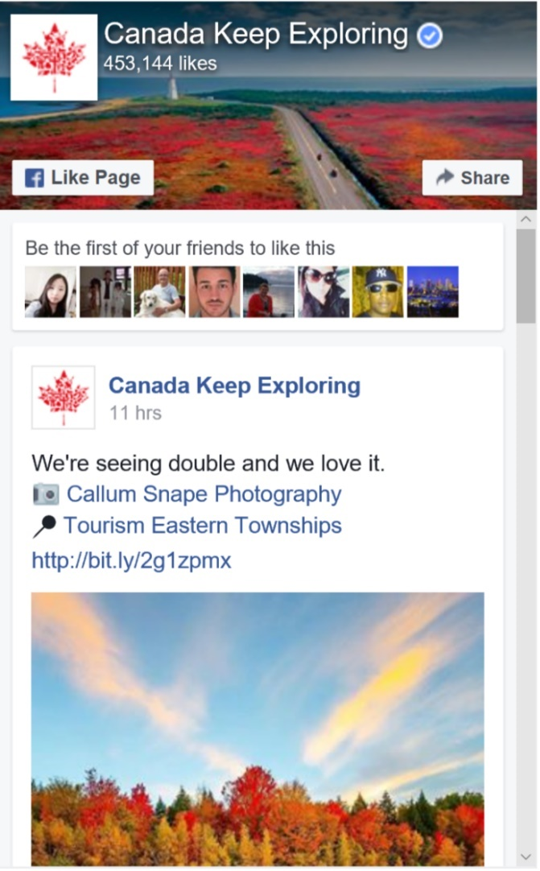

**Do you have what it takes to be a hardboiled detective? Probably not.**

**Noir Daily**

**543,234 likes**





Hardboiled detectives are the definition of cool. Take this quiz to find out if you’re as awesome as they are.

Posted on November 15, 2016, at 4:06 pm

**Noir Daily**



**Noir Daily**

Brand Publisher



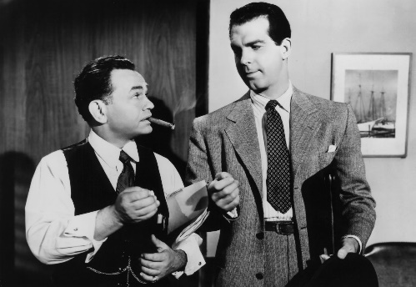

1. Do you keep your cool under pressure?



No

Yes

**How to Identify the Femme**

**Fatale**

**Top Posts From Noir Daily**

Hardboiled detectives never seem to break a sweat. Think of the coolest guy you know, then think ten times cooler. Are you that guy? Probably not. This dude can take a punch to the kidney, a bullet to the arm, and a stab in the heart without flinching. If you’re this badass, you probably eat raw eggs for breakfast while listening to N.W.A.

[](https://www.bing.com/images/search?q=noir&view=detailv2&&id=7DA03BB15D1D2AFC8FB89B2BE279E1423F2EFEBE&selectedIndex=3&ccid=bBDtZo53&simid=608046965232962327&thid=OIP.M6c10ed668e774b8f2d43c37fee45f2c5H0)

2. Are you a cynical person?

No

Yes

**What cigarette would you smoke if you were a detective?**

If you get annoyed with everyone and think that the world is inherently evil and selfish, you fit part of the description of a hardboiled detective. You’re that friend who takes charge of everything because you don’t trust anyone else. You want the world to be a good place and for everyone to enjoy it, but you know deep down that people are selfish. Hardboiled detectives doubt everyone and everything.



3. Choose all that apply:



**How much do you know about noir?**

**What antihero are you?**

**5 Signs You’re a Vixen**

 You think the police force is corrupt/inept

 You can drink scotch like water

 You’re mysterious

 You have “street smarts”

 You’re persistent

 You take things into your own hands

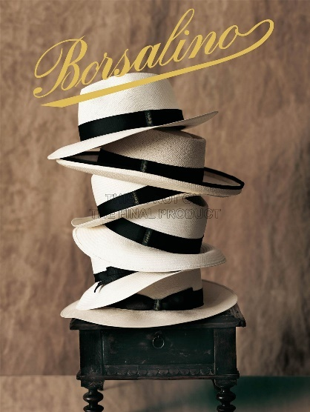

4. Do you own a fedora?

Owning at least one fedora is a prerequisite for being a hardboiled detective. I mean, come on, look at this:

[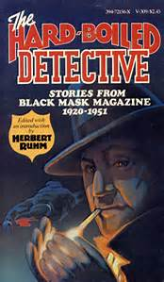](https://www.bing.com/images/search?q=hardboiled+detective&view=detailv2&&id=1187798EF85C162AD1BCD4FF9AC6719199CB7D85&selectedIndex=0&ccid=NV3PzU3X&simid=607997302530375902&thid=OIP.M355dcfcd4dd7e2728738986f0416352fH0) [](https://www.bing.com/images/search?q=hardboiled+detective&view=detailv2&&id=56E7F04AA41C7324FDBEF909B486246B9FE8F59C&selectedIndex=3&ccid=BA3JjhXp&simid=608048820666958723&thid=OIP.M040dc98e15e9925ed49b875542b0dfeeo0)[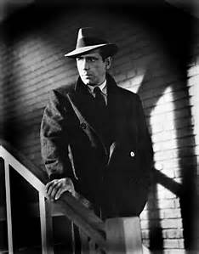](https://www.bing.com/images/search?q=hardboiled+detective&view=detailv2&&id=74D912376CC327A7636EED09D4393166D9C48859&selectedIndex=5&ccid=hTQFNXk9&simid=608038985195128289&thid=OIP.M85340535793d963ac0b301a8638c8047H0)[](https://www.bing.com/images/search?q=hardboiled+detective&view=detailv2&&id=D591640EE5926972F20CBDEE11152F2B065518C9&selectedIndex=17&ccid=BdaxMCyW&simid=608046724718593236&thid=OIP.M05d6b1302c967a1b7251c8701218ede1o2)[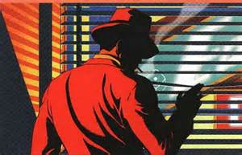](https://www.bing.com/images/search?q=hardboiled+detective&view=detailv2&&id=168CF897602C41E08DEB4BB3288129FEC6BA3547&selectedIndex=22&ccid=Akufys37&simid=607991719083575954&thid=OIP.M024b9fcacdfbe238d3324f6f84d607fco0)

One quick google images search of hardboiled detective and every single one of these guys has fedora. It’s hard to not look mysterious and edgy with one of these bad boys on. Don’t forget the dull-looking suit.



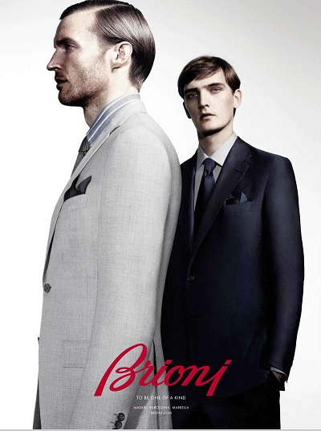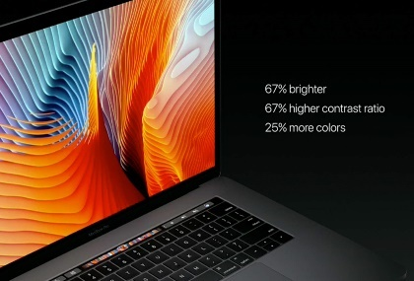

**Buy a Fedora NOW**

5. Are you a guy?

 

No

Yes

Sorry ladies, but hardboiled detectives in classic noir are always dudes. Don’t let this get in your way of being one! If you have all the other characteristics but you’re not a guy, consider yourself a modern hardboiled detective. Think about the time classic noir was created. We all know today that you girls could probably do it better.

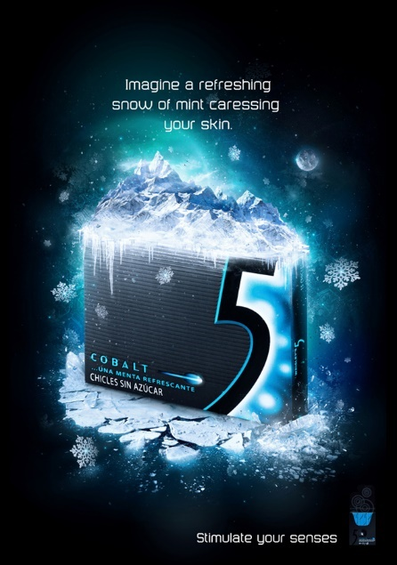

Overall Score

0-5:

You’re not very hardboiled nor do you have the characteristics of a detective. You probably love the world and dismiss the corruption that goes on around you. Not that that’s a bad thing, as you are probably very happy and truthful to those around you. You do you, only a certain group of people can be classified as hardboiled detectives.

[](https://www.bing.com/images/search?q=happy+person&view=detailv2&&id=F90B472537A54BF0781622993BA7978FBEFFA63D&selectedIndex=2&ccid=Pe17thoS&simid=608034694519456469&thid=OIP.M3ded7bb61a12a5edde66c4069189ae35o0)

6-8:

Not bad. You’re probably nice to everyone but have enough sense to know that the world isn’t a good place. You take things into your own hands but get a little antsy when things get stressful. With some practice, you can easily become a hardboiled detective.

[](https://www.bing.com/images/search?q=fedora+and+suit&view=detailv2&&id=0AB85BEF69A009D8D704D1BD30C0BD031679FA27&selectedIndex=115&ccid=NcGnH6Co&simid=608033620767343547&thid=OIP.M35c1a71fa0a8818ed9fb14cc0fd4c010o0)

[](https://www.bing.com/images/search?q=cigarette+advertisement&view=detailv2&&id=3B22CAF76DB0D2CD7C589FDA21C6EB167EBBEDE8&selectedIndex=19&ccid=Zl0RvKce&simid=607996160075040924&thid=OIP.M665d11bca71e4859f00ef77491f04332o0)

[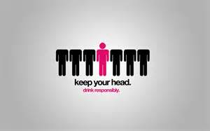](https://www.bing.com/images/search?q=Simple+Advertisements&view=detailv2&&id=420D1D029FB76050D6C9C6B264C6A13FA5EF6F4A&selectedIndex=32&ccid=%2fW0aIIpK&simid=608015899735494212&thid=OIP.Mfd6d1a208a4a6d14c3d1d876f855ab81o0)

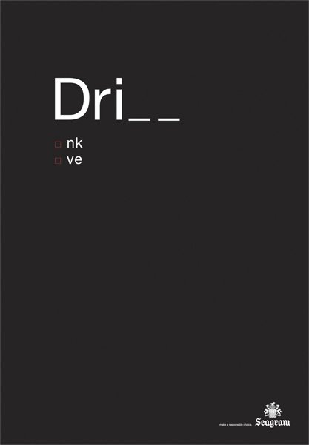

9-10:

Damn, that fedora looks good on you. You have everythings it takes to be a hardboiled detective. Your wittiness probably gets you through a lot of sticky situations, and your charm lands you a spot in the arms of anyone you desire. Don’t let your confidence get in the way, because it’s a corrupt world out there, but you know that. Lean back, kick your feet up, and keep sippin’ that scotch because there’s nothing more you need to do to be a hardboiled detective.

[](https://www.bing.com/images/search?q=fedora+suit+cigarette&view=detailv2&&id=CD1A39CF909C0D756DB59E5AF51D77996508C8D0&selectedIndex=100&ccid=BkirZpBX&simid=608002293288603489&thid=OIP.M0648ab669057f008a3228885c3afad36o0)





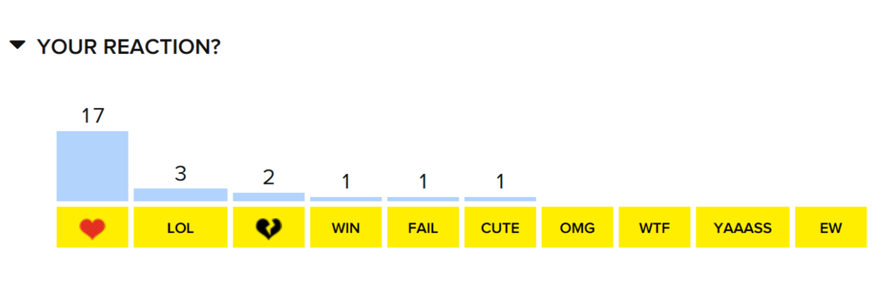







This was dumb…

0-5:

You’re not very hardboiled nor do you have the characteristics of a detective. You probably love the world and dismiss the corruption that goes on around you.

I disagree I can definitely see all the corruption going on.

“Damn, that fedora looks good on you.”

Lol I knew I looked good in fedoras. My kids always tell me not to wear them but I think they’re cool!