Kevin O’Leary
Writing 39B
Professor Ramon
26 November, 2016
Rhetoric in Practice: Testing to See if You’re a Hardboiled Detective
Buzzfeed quizzes, which are typically shared on various social media platforms, present teenagers and young adults the opportunity to reveal a generic, self-related answer to an exaggerated question. They contain everything from social media accessibility to advertisements, and even use humorous slang to appeal to this generation’s internet enthusiasts. To convey these rhetorical strategies and translate them into the genre of noir, it was necessary for me to contain rhetorical knowledge, which The Anteater’s Guide to Reading and Writing defines as “the ability to analyze contexts and audiences and then to act on that analysis in comprehending and creating texts” (Loren Eason et al. 9). My Buzzfeed quiz manipulates a variety of genre rules that connect noir to the quiz, such as through social media representation, images, and a believable (and interactive) menu bar/header. The layout of Buzzfeed and the demographics of its viewers influenced the use of social media links and the menu bar/header of the website. Images were inspired by the assumption that young viewers are attracted to humorous and sexual representations. To manipulate the various rules pertaining to Buzzfeed and the noir genre, I successfully replicated the layout of a Buzzfeed quiz while linking noir to social media and images, ultimately sparking interest in young adults and teenagers who readily use the internet as a source of entertainment.
As with many websites, the demographic of Buzzfeed is a younger crowd: typically teenagers and young adults. According to Craig Smith of Expanded Ramblings, fifty percent of Buzzfeed users are between eighteen and thirty-four years old while seventy-five percent of traffic comes from social media (1). Given the slang and sexual references of many Buzzfeed quizzes, my quiz was geared more toward younger people who browse the internet looking for entertainment. One of noir’s fundamental genre conventions is the dark world, where many people of the time believed that the world was engulfed in corruption. This idea is satisfied by the quiz considering that most people take it for entertainment. It can be said that people browse the web and ultimately take these quizzes to escape from the harsh realities of the world. This audience contains the underlying belief that the world outside of the internet is, at a given time, not worth being a part of, and therefore can be evaded by seeking entertainment on the internet.
One particularly effective move I used was to incorporate social media sharing and a Twitter sidebar of the publisher. The social media sharing links were located both at the top and the bottom of the page, which can be seen within my project:
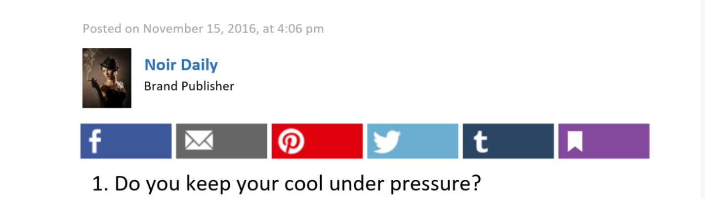
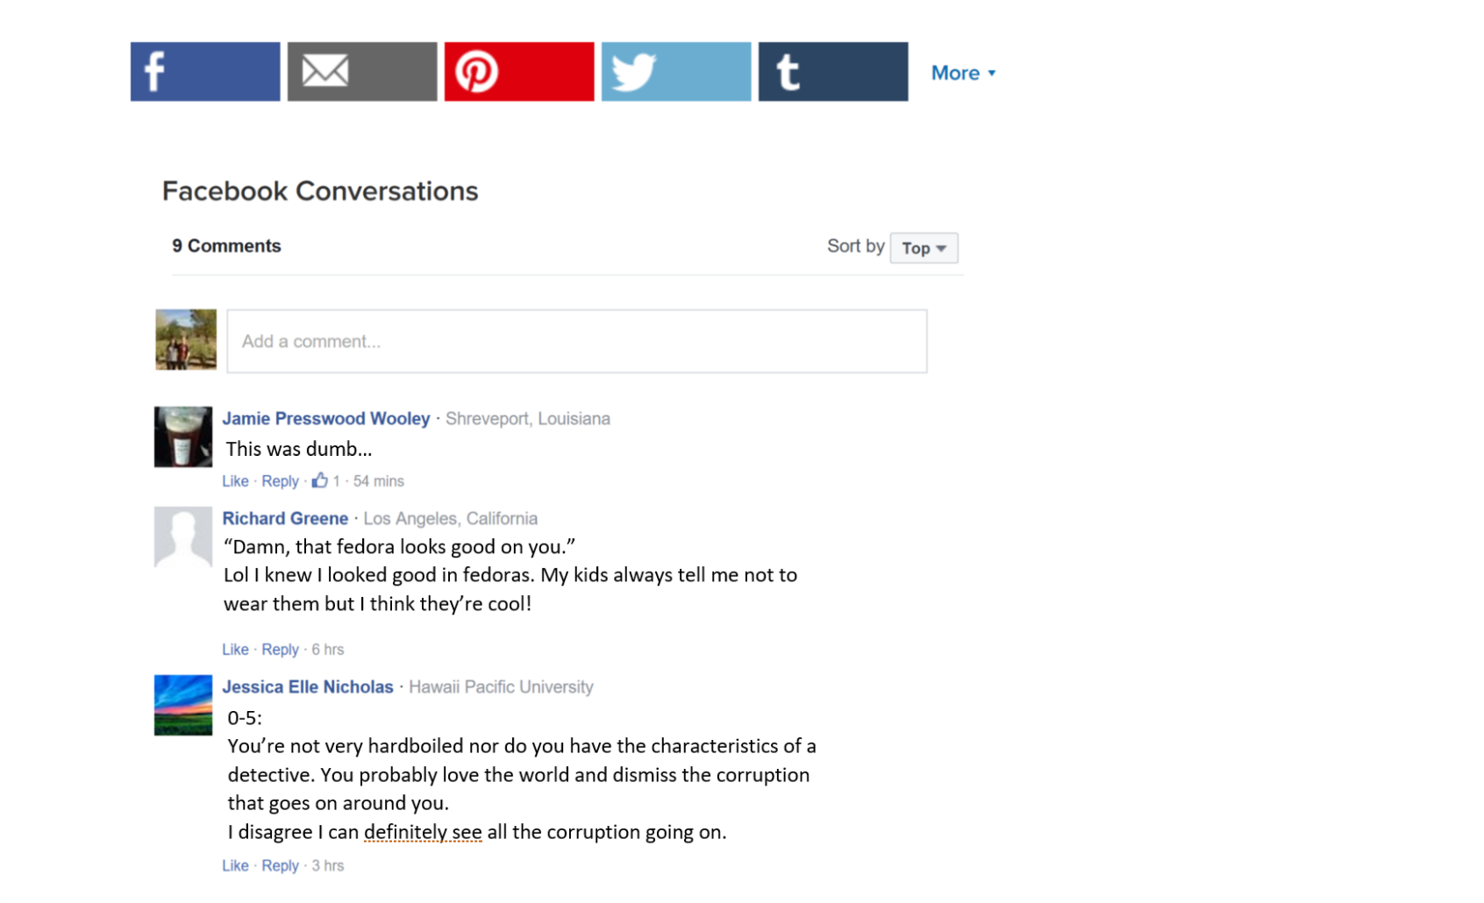
I incorporated the ability to share the quiz before the first question, then again at the bottom near the Facebook comments area, which is another integrated social media concept the website has. I also included a sidebar that shows a few posts from “Noir Daily”, who I made be the publisher. This can be seen here:
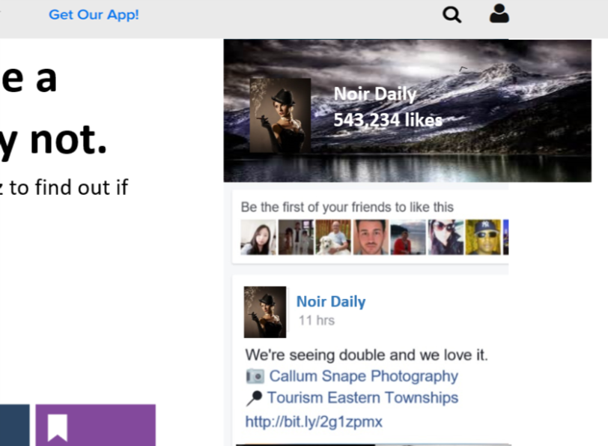
These moves are successful in representing the layout of a typical Buzzfeed quiz and ultimately generate more views for the quiz because people share it. According to Social Media Daily, the “median age of a Facebook user [is] 26” (Morgan). Because Buzzfeed users are so young, it is effective to integrate the ability to share the quiz on social media platforms such as Facebook. But there is also a combination of genres represented in this because the Twitter feed for “Noir Daily” combines the ethos of having a popular social media website (because it has over five hundred thousand likes) with the genre of noir. The audience of this quiz is assumed to be young and active on social media; therefore, these choices can be determined as being successful in persuading the audience to take the quiz for the benefit of their entertainment as they escape from the stress of everyday life.
Images were prominent throughout the quiz and, again, linked the genre of noir with this website. Several images were used within the quiz itself while others lined the edges of the website as links to other quizzes or articles, as can be seen within the page itself:
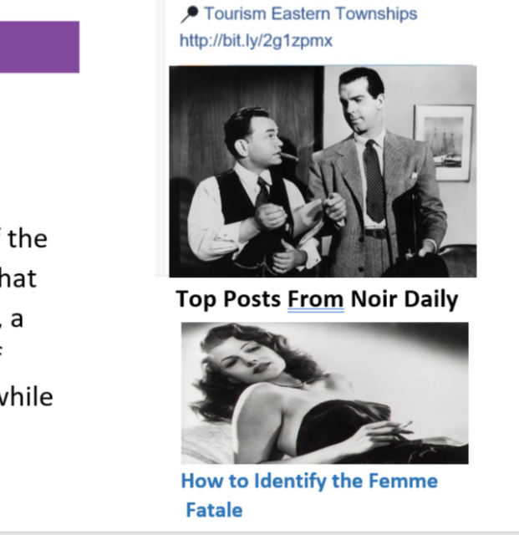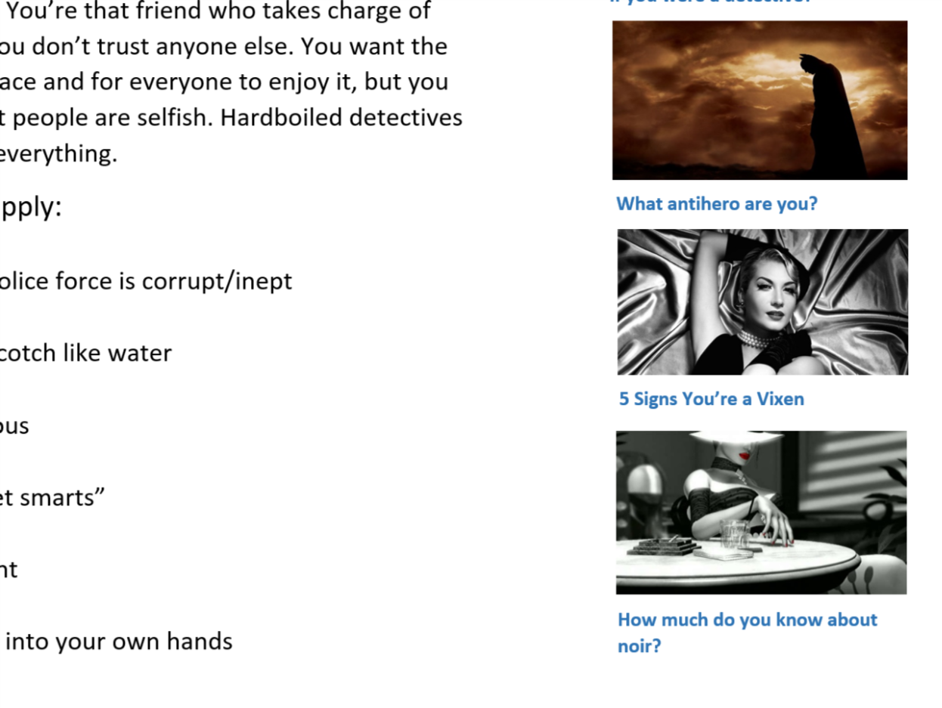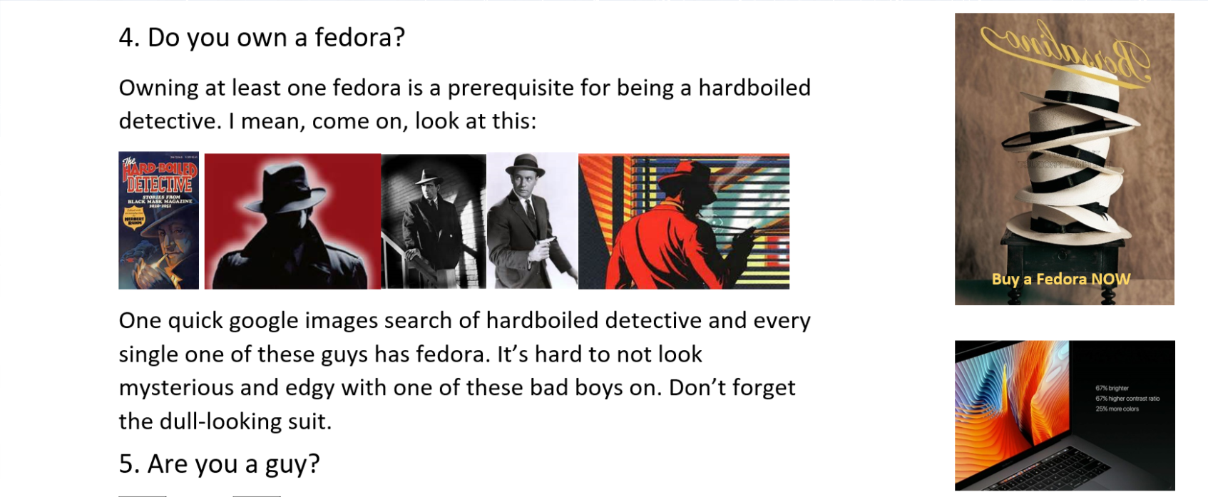
There are too many images to comment on directly; however, many of them relate to each other as they pertain to a rhetorical strategy. Whether they served as links to other quizzes/articles or part of the Twitter feed, pictures of women (typically laying down in a seductive way) were used throughout the page. This strategy was intended to appeal to a younger male (probably single) audience who would eventually look at these images and spend more time on the page. The fedora pictures following the question about fedoras served as a humorous way to maintain the interest of all the young viewers, who are ultimately seeking entertainment. Advertisements such as the new Mac Pro and fedoras also appealed to a younger crowd who typically spend a lot of time on computers and keep up with fashion trends. Except for the Mac Pro advertisement, these moves all relate to noir, such as how they are mostly in black and white and contain characters dressed in clothing from the time of classic noir. Being visually appealing for an audience who values noir while simultaneously appealing to a modern crowd would generate more traffic on the website, proving to be a successful rhetorical strategy.
My header and menu at the top of my page resembled that of Buzzfeed’s, which is attractive to many young users who are active on Buzzfeed or who understand humorous slang. One can observe how the interactive menu contains access to other areas of Buzzfeed with quick links to certain genres that generate a specific emotion:
Though the header and menu look very dull, there are several rhetorical strategies used that appeal to teenagers and young adults. For example, the header’s layout is very simple. Simplicity is a growing trend in modern society, and the simplicity of this header would be appealing to the audience born within the age range of Buzzfeed users. The links on the header and menu bar are also very effective. They are so simple yet the audience understands their meaning, such as the “LOL”, “cute”, and “fail” links. These seem incredibly vague, however, most people browsing the internet are searching for some specific form of entertainment, such as fail videos, cute kittens, or even things that will make someone laugh. A specific form of entertainment can be found within one of these links, which is very appealing for a crowd who uses the internet to escape from the harsh realities of everyday life.
Despite having flaws within my actual writing in my Buzzfeed quiz that may not be attractive to young viewers, the overall layout and visual appeal of the website was effective because it contained images, slang, and social media accessibility, all of which are attractive to young visitors. As a whole, the rhetoric of my website was effective because it achieved its goal of connecting noir to a specific audience, which ranges from teenagers to young adults. My website contained proper formatting and resembled that of a real Buzzfeed quiz. These quizzes are very popular, therefore implying that the establishment of ethos is subsequent to being part of Buzzfeed, thus creating traffic and potentially teaching young viewers about the hardboiled detective of noir.

Works Cited
Morgan, Jacob. "Twitter Demographics." Social Media Today. N.p., 07 Feb. 2015. Web. 27 Nov.
2016.
Smith, Craig. "28 Amazing BuzzFeed Statistics." Expanded Ramblings. DMR, 21 Oct. 2016.
Web. 27 Nov. 2016.
"Why Rhetoric?" The Anteaters Guide to Reading and Writing. Ed. Loren Eason. 5th ed. Irvine:
U of California, Irvine, 2016. 9. Print.

