Mirella Cruz Trinidad
Instructor Fish
Writing 39 C
11 February 2017

Historical Conversations Project
American higher education is highly regarded, on a national and international level, for its research discoveries and prolific innovations. As prestigious and renowned as higher education is, the achievement gap in grades K-12 demonstrates that the education system in the United States is highly flawed. The phenomenon of the achievement gap refers to the difference in performance between minority students and students of privilege, and is more evident in urban areas (Porter 1). Although the achievement gap is a complex and multilayered issue, it can generally be measured in three ways, in “performance on tests”, “access to key opportunities”, and “attainment”, as highlighted by the National Education Association (National Education Association). The terrifying results of National Assessment of Educational Progress (NAEP) – a large national educational assessment that tests American students on mathematics and reading – accurately captures the presence of the achievement gap. Figure one displays the results of the 2015 NAEP in mathematics. Clearly, white, and Asian students outperformed minority students such as African Americans and Hispanics in both the fourth and eighth grade by more than fifteen points (National Education Association). There are numerous factors that contribute to this occurrence, such as the income, family structure, disability, and language barriers of the student. Nonetheless, these factors are all subtly the effects of the years of segregation that existed in the beginning of twentieth century in the United States, and in many ways, continues to exist today (Rothstein, 50). If this problem is not well addressed and solved, there would be more high school drop outs, thus great losses in economic growth and a decrease in the quality of life of the high school drop outs. Without noticing, segregation has empowered the growth of the achievement gap for decades because it has deliberately categorized and separated students into groups, based on income, and race.
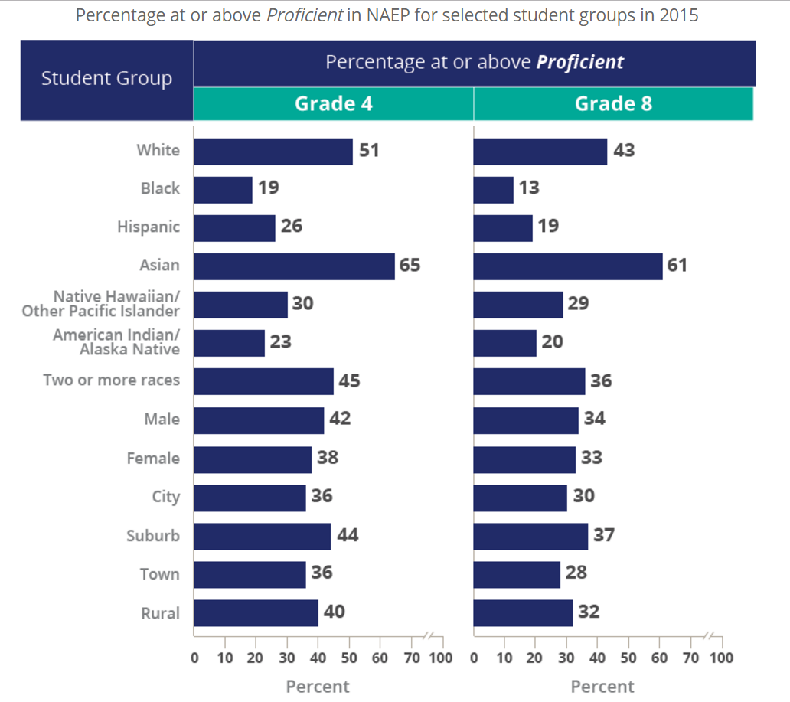
(The Nation’s Report Card.)
Figure 1. This is a chart is taken from the website nationsreportcard.gov. Presented here is the percentage of proficiency in mathematics of various groups for the fourth and eighth grades in the year 2015. It is evident that 2hite and Asians perform better than minority students by more than ten points. It is important to notice that there is also a gap of between 2hites and Asians in both the fourth and eighth grade.
For decades, residential segregation has forced minority and low income families to move to the inner cities in which there are little resources and an abundance of struggles (Rothstein, 51). This is evident all over the nation from Missouri, to Massachusetts. Starting with the Supreme Court’s approval of the “separate but equal” doctrine in Plessy v. Ferguson (1896), legislation all over the nation deliberately focused on segregating minorities (most notably blacks) from whites (Rothstein, 51). During the New Deal, when housing was in high demand, the Federal Housing Administration allowed whites to move to the suburbs for cheap, and with good benefits such as generous loans to build houses, which were not given to blacks; furthermore, blacks were prohibited from buying resold houses (Rothstein, 30). Figure 2 depicts the promotion of segregation in the state of Missouri. This is significant because this demonstrates that blacks and minorities were practically pushed away. The black communities were badly built and given less importance, than the communities of their white counterparts (). That explains why today low performance in schools exist in low income communities. There is a high correlation between low income and high concentrations of minorities in a city, or location. Throughout the years there has been an increase in the number of minorities students attending a school with higher low income students (Rothstein, 51). Schools with 90 percent minorities attending it, increased from “34 percent in 1989 to 39 percent in 2007” (Rothstein, 51). Similarly, the number of low income students attending city schools has increased from 43 percent in 1989 to 59 percent in 2007 (Rothstein, 51). It is important to note that the stresses low income students endure leads to the shift of focus of the school from academics to conduct classes (Rothstein, 51). In Ferguson, Missouri and urban city, there are low proficiency rates in 6th and 7th grade: as of 2015, only 30 percent were proficient and 25 percent were proficient in reading (Rothstein, 29). Likewise, only 14 percent of the city’s young adult population “have bachelor’s degrees, compared with 35 percent nationwide” (Rothstein, 29). The reason why students perform badly in low income neighborhoods, like inner cities, is because they are under severe hardships, such as hunger, illness, absence, and more. Richard Rothstein explains in his academic journal, that “no matter how well-trained the teachers, no matter how well designed the standards and curriculum,” it is difficult for students living in poor communities, like Ferguson, to succeed (Rothstein, 29).
Figure 2. This is an image taken from the scholarly article, “The Story Behind Ferguson”, which was taken from the Missouri History museum. The image demonstrates that the persistent deeds that promoted segregation in the state of Missouri. The image is a flyer that tries to convince whites that segregation is a good thing. The flyer portrays blacks as dangerous and chaotic, thus making their point appealing. Flyers like these pave way for residential segregation, segregation by housing.
The government is the most responsible for the persistency of the achievement gap. As mentioned, earlier the government has often attempted to segregate whites from minorities, through important legislation and housing policies passed during the New Deal agency under president Franklin D. Roosevelt (Rothstein, 30). The policies, made by the Federal Housing Administration (FHA), not only facilitated whites to move to the suburbs by giving easy processed loans, but also by selling the houses for inexpensive prices (Rothstein, 30). By 1943, the FHA was overseeing of 80 percent “of all private home construction nationwide” which in effect, paved way for a segregated America. Early in the 1950s the Federal Housing Administration (FHA) so houses “for as little as about $8,000 – about $125,000 in today’s terms,” and blacks, on the other hand were forbidden to buy these houses even if they could afford it (Rothstein, 30). The Fair Housing Act of 1968 ended the prohibition of blacks from purchasing houses in the suburbs, however, it was too late (Rothstein, 31). The houses were too expensive, and the minority community was profoundly scarred. African American and minority students were already behind their white and Asian neighbors in academics. If the government would have halted the FHA and other agencies from making extremely biased and racist policies, there would have not been a development of the “ghettos”, where low income and minorities, mainly blacks, lived. Students would have not experienced severe stress from constant violence in communities, and no quiet house to study. Thus, the victims of the federal laws that allowed segregation suffered the most. Charlotte Ringsmose, professor from the Aarhus University, Denmark, gives her perspective on how children are affected when they live in low income communities, like the “ghettos” in which minorities lived in during the de jure segregation times. Ringsmose claims that despite the government’s good job with helping its citizens have good healthcare, housing and healthy food, “socioeconomic differences provide children with different social positions in society from very early on” (Ringsmose, 186). Students with parents who have little education tend to do worse in school and are least likely to experience social mobility (Ringsmose, 186). If Denmark witnesses disparities with its students, despite its great distribution of resources, the United States, a capitalist country who has so many flaws in the distribution of wealth must experience this disparity and pattern more. Without a doubt, students in low income communities suffer the most.
If the achievement gap is not narrowed faster, there would be more high school dropouts causing the United States to lose more dollars, and students to drastically decrease their quality of life. As of now, every year, there are more than 1.2 million dropouts, equivalent to the population of San Diego (Amos, 2). The decomposition of graduation rates of different groups are displayed in Figure 3, below. Figure 3, once again, demonstrates that there is certainly a gap in achievement, for less African Americans and Hispanics attain a high school diploma compared to Asian Americans and whites. According to Jason Amos writer of the article, “Dropouts, Diplomas, and Dollars: U. S. High Schools and the Nation’s Economy,” one high school dropout “costs the nation $260,000 in lost earnings, taxes, and productivity” (Amos, 2). Not only does the lack of education dramatically decrease the opportunities for the dropouts but also, increases their chances of being “arrested, or incarcerated” (Amos, 2). Both economic and social aspects are compelling reasons to urge law makers, and the government to do something about the achievement gap. Our students need support to succeed.
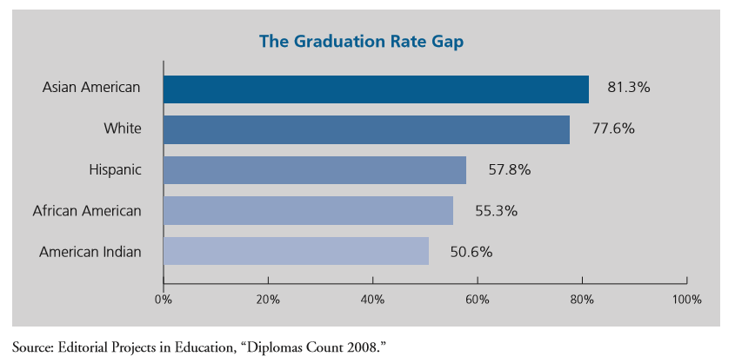
Figure 3. This is an image taken from the scholarly article, “Dropouts, Diplomas, and Dollars: U. S. High Schools and the Nation’s Economy,” which was taken from the Editorial Projects in Education. The image illustrates the graduation rates of different groups in the United States. Clearly, there is a big difference in graduation rates between Asian Americans, and whites, and African American and Hispanic students, which clearly reflects the effects of the achievement gap, because attainment is less for students of certain backgrounds.
There is a shallowness when critics claim that the achievement gap is decreasing and that the causes of the achievement gap no longer exist. Critics do not take into account the different levels of complexity of this issue, such as the history that paved way for the education gap. After the unjust housing legislation in the twentieth century, mentioned earlier, there have been several attempts to narrow the achievement gap, such as busing minority students to predominately white schools for the sole purpose of desegregating schools (Orfield, 6). David Armor, a fervent oppose of busing and school desegregation conducted a study in which minority students were taken to a better school for two years and then compared them to their siblings (Orfield, 6). The research ended in a failure, for the control groups and the results were false and skewed; he did not prove that busing was a failure (Orfield, 6). In a research study called the Harvard Civil Rights Project, in Boston, Massachusetts, Gary Orfield, one of the researchers, explains that a group of about 3,200 students from the inner city of Boston were given the opportunity to attend a school with better opportunities, this occurred through the program Metropolitan Council on Educational Opportunities (METCO). However, they discovered that desegregation does not increase the “intelligence” of a student, but rather increased their stay in school (Orfield, 6). Furthermore, it was discovered that parents continued to support their children, despite their child’s commute (Orfield, 6). It is a common thought that due to the low income of the people living in certain communities, schools are ill-developed, and the quality of the teaching is not sufficient. However, this is partially false because it a student is affected by their surroundings, and the knowledge they gained when they were small.
Although issue of the achievement gap has multiple levels of complexity, past segregation and modern segregation in the United States is responsible for the various components that contribute to the achievement of children. These setbacks prevent students from succeeding and makes them prone to delinquency, government dependence and a lower standard of living. For that reason, there must be a persistent force that fights against the disparities that the achievement gap imposes. Students should have the opportunity to graduate high school, pursue a higher education and live life freely, without and obstacles or affirmations that they will fail. The fight for equality in schools will continue.

Works Cited
Amos, Jason. Dropouts, Diplomas, and Dollars U.S. High Schools and the Nation's Economy. Alliance for Excellent Education . August 2008. 09 February 2017.
National Education Association. Identifying Achievement Gap and Community. 2002. February 2017. <http://www.nea.org/home/12464.htm>.
Orfield, Gary. Summary of "City-Suburban Desegregation: Parent and Student Perspectives in Metropolitan Boston," a Report by the Harvard Civil Rights Project. Vol. 31. 09 July 2006. 10 February 2017.
Ringmose, Charlotte. Social Welfare and Minding the Achievement Gap (Aview from Denmark)\. 2012. 2017.
Rothstein, Richard. The Story Behind Ferguson. March 2015. Article. February 2017.
Rothstein, Richard. Why Our Schools Are Segregated. May 2013. 11 February 2017.
The Nation's Report Card. 2015 Mathematics and Reading Assessments. 2015. February 2017. <https://www.nationsreportcard.gov/reading_math_2015/#mathematics?grade=4>.

Bibliography
Amos, Jason. Dropouts, Diplomas, and Dollars U.S. High Schools and the Nation's Economy. Alliance for Excellent Education . August 2008. 09 February 2017.
This article provided a lot of solid information regarding the effects of the achievement gap. The source is reliable because it is from the Alliance for Excellent Education which supports the growth and perfection of the education system. This was an integral part of my research paper because it gave me insight regarding the actual effects of the achievement gap on a national level.

Orfield, Gary. Summary of "City-Suburban Desegregation: Parent and Student Perspectives in Metropolitan Boston," a Report by the Harvard Civil Rights Project. Vol. 31. 09 July 2006. 10 February 2017.
This article was a key source for my research paper, for it provided numerous of counterarguments regarding the causes of the achievement gap. This was definitely helpful because it also was key evidence to prove that the achievement gap was mainly located in inner cities. The source is reliable because a researcher from the University of Harvard wrote it, and conducted the research.

Ringmose, Charlotte. Social Welfare and Minding the Achievement Gap (Aview from Denmark)\. 2012. 2017.
This source was important because it provided a different perspective regarding the achievement gap in an international level. The author is credible because she is a professor at the Aarhus University of Denmark. I used the information of this article to help me identify some key features that exist in the achievement gap, despite its location.

Rothstein, Richard. The Story Behind Ferguson. March 2015. Article. February 2017.
This was important for my research paper because it gave me insight regarding the actual effects of the achievement gap on a national level. The source is reliable because the author is a researcher in the field of Economics of the University of California Berkeley. A lot of my arguments were influenced on this article. This also provided the images I used for my research paper.

