Siyu Ren
Brendan Shapiro
Writing 39C
October 27, 2015
“War on Drugs:” Cannabis Ads Challenge the First Amendment
Some states such as Oregon and Colorado have recently legalized marijuana in the public market. Legalizing marijuana brought decent economic growth in these states because of high taxes implied on marijuana, as well as its medical benefits for Alzheimer’s disease, Parkinson’s disease, and even cancer. However, there has been a raising controversy over restricting cannabis advertisements due to several social problems and health issues caused by the drug. According to Nicole Walden and Mitch Earleywine, two recognized researchers on cannabis-related problems, both frequency and quantity of cannabis used is positively correlated to social problems including “getting into trouble at work, getting into fights, or losing friends.” Although most Americans consider marijuana a modest drug, the US federal government categorizes marijuana with heroin, LSD, and other fierce drugs that can lead to death (Weiss and Dilks). Consequently, the public fears abusive use of cannabis ads would increase the use of marijuana on nonmedical users and draw young people to drug addiction. Many teens and young adults believe marijuana does little harm because it is used for medical purposes, but studies show that “marijuana users at college are more likely than non-users to engage in heavy drinking, to use additional drugs, and to consume these substances in a ‘party’ environment that encourages high-risk consumption and often risk-taking behaviors” (Weiss and Wilks). Recent cultural changes have made this problem distinct from the past. As our society develops, citizens are more concerned with health issues.

The public’s concern of marijuana has urged state governments to regulate cannabis advertising in many marijuana-legalized states by restricting publications, yet some publications refuse to comply under the protection of First Amendment. A year after Colorado legalized a statewide drug policy for marijuana in 2012, the state passed a law that “require stores to place marijuana-themed magazines behind the counter if they allow patrons under 21” ("Magazine Fights"). The law prevents magazines that contain cannabis ads on store racks because parents complained that unrestricted press of cannabis ads is too visible to children ("Magazine Fights"). However, under the protection of the First Amendment embodied in the US constitution, High Times, Westword, and two other publications refused to keep their magazines behind the counter. In 2014, High Times filed a federal lawsuit arguing that Colorado’s restriction on advertisement violates the right to free speech guaranteed in the First Amendment. The argument brings back the case of Central Hudson Gas & Electric Corp. v. Public Service Commission in 1980, which challenged the restriction on commercial speech.
Figure 2 Cannabis ad published in Westword magazine that was asked to remove from store racks.
Source: "Does The First Amendment Protect Marijuana Ads?" Forbes. Forbes Magazine, 19 Feb. 2014. Web. 6 Oct. 2015.

One of the most prominent cases that protected advertising and commercial speech was Central Hudson Gas & Electric Corp. v. Public Service Commission. The Central Hudson utility company sued Public Service Commission for prohibiting advertisements that promote use of electricity. The Supreme Court finalized the case ruling “a state must justify restrictions on truthful, nonmisleading commercial speech by demonstrating that its actions ‘directly advance’ a substantial state interest and are no more extensive than necessary to serve that interest” ("Central Hudson"). Therefore, Colorado’s restriction of cannabis ads would be struck down as unconstitutional because the ads are “truthful and nonmisleading.” Jacob Sullum, the author of Saying Yes: In Defense of Drug Use, adds to the argument in his anti-drug blog on Forbes that although the First Amendment protects commercial speech when it “addresses lawful activity…and is not deceptive, false, or misleading,” marijuana is not legalized in all U.S. states, thus, cannabis advertising fails to count as a “lawful activity” on federal basis (Sullum). In this case, the claim by High Times magazine would be struck down as unconstitutional instead.
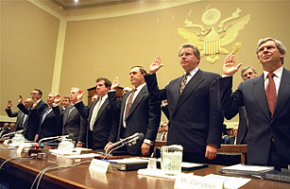
Another case that would overturn Colorado’s advertising regulations was Lorillard Tobacco v. Reilly held in 2001. Attorney General of Massachusetts, Thomas F. Reilly, was challenged for enforcing regulations governing the advertisement and sale of tobacco. Yet, his concerns for citizen’s health was surprisingly accused of violating the First Amendment under Central Hudson Gas & Electric Corp. v. Public Service Commission for outdoor advertising regulations and sales. After justifications and analysis, the court decided the restrictions on tobacco are unnecessary ("Lorillard Tobacco”). As marijuana legalization gradually expands over the United States, the controversy on restricting cannabis ads emerges similarly to the tobacco advertising market.
Figure 2 In 1994, seven heads of Big Tobacco companies swore infamously that nicotine was not addictive before a congressional subcommittee.
Source: "Big Tobacco = Big Money = Big Headaches." Management Review 83.10 (1994): 48. Print
It is likely that restriction on marijuana advertisements in the pot market will eventually duplicate the Big Tobacco in which the industry was viciously hit by advertising regulations. In particular, the Big Tobacco refers to major tobacco companies including Lorillard Tobacco, which intends to make as much profit as possible while ignoring its harm. However, the industry faces several challenge in the 20th century (Andelman). In 1997, the Tobacco Master Settlement Agreement “banned outdoor, billboard, and public transportation advertising of cigarettes in 46 states” (Madrak). The agreement also “prohibited tobacco advertising that targets young people and the usage of cartoons…in association with their products” (Madrak). The regulation caused significant damage to the market of tobacco. Many experts in cannabis lawsuit like Attorney Vincent Sliwoski “expects the Oregon Liquor Control Commission to restrict pot advertising similar to the way Washington and Colorado have done, likely following current tobacco and liquor ad rules” (qtd. in Deutsch). In 2013, Colorado imposed a law that banned cannabis ads in several media and publishers such as radio, TV, and teenage magazines with more than 70 percent of audiences under the age of 21 (Sullum). Similar to the Tobacco Master Settlement Agreement, Colorado’s recent regulation on marijuana “prohibits the use of cartoon characters or other images that could be seen as appealing to kids” (“Magazine Fights”). The regulations forecast a new Big Marijuana industry that is not only feared by marijuana retailers but also publishers who seek to stack their revenue stream with the growing marijuana market. With such economic incentive, publishers like High Times and Westword relentlessly argue their right to commercial speech, therefore, they should not be suppressed under libel. Although the open market of marijuana in Colorado sparked some local advertising agencies, the marijuana industry is continuously growing into a replica of the Big Tobacco where marijuana advertising suffers the same restrictive fate.
Publications like High Times and Westword may be taking too much advantage in marijuana-legalized states with the backing of the First Amendment. Some conservative states call an absolute crime to manufacture, retail or consume marijuana, much like the Prohibition the 1920s. The Eighteenth Amendment was ratified in the U.S. constitution during Prohibition, which “took away license to do business from the brewers, distillers, vintners, and the wholesale and retail sellers of alcoholic beverages” (“Why Prohibition?”). Alison Holcomb, a drug policy director of the American Civil Liberties Union, argue against states that prohibit marijuana because “prohibition fails our society's normative standards of what should be labeled a crime.” Holcomb defines “crime” as “acts that are so bad—that inflict such grievous harm on others—that the offender deserves to be arrested, dragged through court, jailed, and saddled with a criminal record.” In a sense of generosity, it is unethical to convict people who sell or smoke marijuana without “grievous harm on others” and permanently print their names on criminal record. In Holcomb’s argument, she makes another point that “If we can agree that the decision to treat marijuana use as a crime deserves revisiting, then we must grapple with the question of how the demand for marijuana will be met.” When alcohol consumption was considered a crime, Americans roared with disapproval and many refused to comply punishments. Instead of realizing the harm of alcohol and cutting consumption down, which the Prohibition intended, crime rates increased due to smuggling and the violent black market for liquor. This resembles the states that prohibit Marijuana. Ever since the Twenty-first Amendment that overthrew Prohibition in 1933, we learned our lesson from a harsh prohibition of necessities. Therefore, Holcomb recommends a new approach on controlling marijuana, such as regulations on advertising (Holcomb).
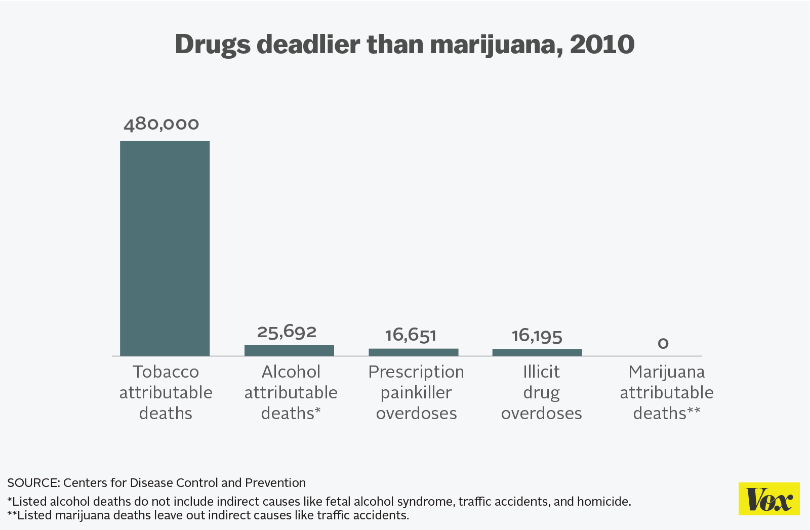
Most opponents of cannabis ads are also those who oppose marijuana legalization because they worry about the health and social damages resulted from marijuana use, especially on young people. David G. Evans, a special adviser to the Drug Free America Foundation, warns that marijuana use not only impair brain development, but also affect teens to “engage in delinquent and dangerous behavior, and experience increased risk of schizophrenia and depression, including being three times more likely to have suicidal thoughts.” Increasing cannabis advertisements ultimately increase damages on young people. Evans utilizes the consequences of marijuana use to argue the cost of legalizing marijuana outweighs its benefits. His argument dissent advertising agencies who look up to enhance their revenue and the U.S. economy with rising marijuana market. In his point of view, the “costs from health and mental wellness problems, accidents, and damage to our economic productivity will far out strip any tax obtained [on marijuana]” (Evans). As a matter of fact, marijuana legalization will only bring burden to the economy since the federal government has to deal with the “costs” that come with marijuana use.
Among extreme opponents on legalizing marijuana, Paul Armentano, the deputy director of the National Organization for the Reform of Marijuana Laws (NORML), offers justification on health issues caused by cannabis. Despite the harm that marijuana brings, Armentano supports his argument with a study in 2009 that estimated “health-related costs per user are eight times higher for drinkers of alcoholic beverages—and more than 40 times higher for tobacco smokers—than they are for those who consume cannabis.” If tobacco and liquor are legal, so should marijuana.
Figure 3 The table shows that tobacco caused the highest number of direct deaths in the year 2010, followed by alcohol. There have never been any deaths directly linked to a marijuana overdose or marijuana-caused health problems.
Source: "President Obama Turns down Joint, Consumes More Dangerous Drug." Vox. Vox Media, Inc., 9 July 2014. Web. 27 Oct. 2015.
Armentano also considered Americans failing experiment with Prohibition in the 1920s and realizes that another prohibition would fall short since teen’s “use of cannabis is rising and has now surpassed the number of teens consuming tobacco,” it would be difficult to prohibit marijuana (Armentano). Armentano understands that although drugs like marijuana are legally retailed in some states, it is hard to avoid incentives of cannabis ads that would urge buyers of different ages, including minors who are illegal to purchase. Considering the dispute of cannabis advertisements while siding with advocates of marijuana legalization, Armentano believes:
“a pragmatic regulatory framework that allows for limited, licensed production and sale of cannabis to adults—but restricts use among young people—would best reduce risks associated with its use or abuse… it's legalization, regulation and public education—coupled with the enforcement of age restrictions—that most effectively keeps mind-altering substances out of the hands of children.”
Consequently, this “restriction” applies to cannabis advertisements, yet many publishers in marijuana-legalized states are unrest with the restriction imposed.
The new century of drug revolution has escalated multiple opinions and debates on the definition of the First Amendment in regards to commercial speech. Even though Colorado temporarily settled the public who fear negative influences of cannabis ads by imposing advertisement restrictions, publishers will not compromise as long as the unwarranted protection of free speech exists in the U.S. constitution. Hence, the U.S. federal government must, therefore, apply new strategies in laws and regulations. The dispute over Colorado's regulations on marijuana advertisement may follow in the footsteps of those on the tobacco and alcohol industries, or it might be the beginning of a new type of regulatory system for commercial speech. Although unpredictable, the future resolution with the cannabis ads issue may follow the path of tobacco and liquor regulations. However, the resentment towards regulation on cannabis ads that obstruct publishers from their free speech rights remains unanswered by the courts.

Works Cited
Alderman, David A. "Big Tobacco = Big Money = Big Headaches." Management Review 83.10
(1994): 48. Print.
Armentano, Paul. "Marijuana Regulation Works and Prohibition Fails." US News.
U.S.News & World Report, 30 Oct. 2012. Web. 19 Oct. 2015.
"Central Hudson Gas & Electric Corp. Full Text." Law Publish. JLCom Publishing Co., LLC.
Web. 13 Oct. 2015.
Deutsch, Marilyn. "Expect to See Ads for Pot as Recreational Sales Becomes Legal." Fox
12 Oregon. KPTV-KPDX Broadcasting Corporation, 30 Sept. 2105. Web. 6 Oct. 2015.
Evans, David G. "Marijuana Legalization's Costs Outweigh Its Benefits." US News. US
News & World Report LP., 30 Oct. 2012. Web. 18 Oct. 2015.
Holcomb, Alison. "Marijuana Use Should Not Be a Crime." US News. US News &
World Report LP., 30 Oct. 2012. Web. 18 Oct. 2015.
"Lorillard Tobacco Co. v. Reilly." FindLaw. FindLaw, 2001. Web. 13 Oct. 2015.
Madrak, Jeff. "Building Big Marijuana: Marketing and Advertising for the Brave." Drug Law
and Policy. Wordpress, 30 Mar. 2015. Web. 23 Oct. 2015.
"Magazine Fights Colorado Limit on Pot Publication." First Amendment Center. First
Amendment Center, 30 May 2013. Web. 13 Oct. 2015.
Sullum, Jacob. "Does The First Amendment Protect Marijuana Ads?" Forbes. Forbes
Magazine, 19 Feb. 2014. Web. 6 Oct. 2015.
"Vincent Sliwoski | Harris Moure." Harris Moure. Harris Moure. Web. 13 Oct. 2015.
Walden, Nicole, and Mitch Earleywine. "How High: Quantity as a Predictor of Cannabis-related
Problems." Harm Reduction Journal Harm Reduct J (2008): 20. Print.
Weiss, Karen G., and Lisa M. Dilks. "Marijuana, Gender, and Health-Related Harms:
Disentangling Marijuana's Contribution to Risk in a College “Party” Context."
Sociological Spectrum (2015): 254-70. Print.
"Why Prohibition?" Temperance & Prohibition. The Ohio State University. Web. 18 Oct.
2015.

